**REPUBLIC OF TURKEY**

**HASAN KALYONCU UNIVERSITY**

**FACULTY OF ENGINEERING**

**COMPUTER ENGINEERING DEPARTMENT**



**DETECTIVE GAME CREATED USING VR TECHNOLOGY**

**GRADUATION PROJECT REPORT**

**Ali Cem GÜLÇİÇEK**

**Kübra ÖZCAN**

**Onat GENCER**

**Samed Uğur ZAMAN**

**Supervisor**

**Prof. Dr. Muhammet Fatih HASOĞLU**

**GAZİANTEP 2023**

**MECILLA**

**JUNE**

**2023**

**Graduation Project in Computer Engineering Department**

**HASAN KALYONCU UNIVERSITY**

**FACULTY OF ENGINEERING**

**COMPUTER OF ENGINEERING DEPARTMENT**



**DETECTIVE GAME CREATED USING VR TECHNOLOGY**

**GRADUATION PROJECT**

**IN**

**COMPUTER ENGINEERING**

**BY**

**Ali Cem GÜLÇİÇEK**

**Kübra ÖZCAN**

**Onat GENCER**

**Samed Uğur ZAMAN**

**JUNE 2023**

**DETECTIVE GAME CREATED USING VR TECHNOLOGY**

**Graduation Project**

**in**

**Computer Engineering**

**Hasan Kalyoncu University**

**Supervisor**

**Prof. Dr. Muhammet Fatih HASOĞLU**

**By**

**Ali Cem GÜLÇİÇEK**

**Kübra ÖZCAN**

**Onat GENCER**

**Samed Uğur ZAMAN**

**June 2023**

Copyright © 2020 Orchard Management And Tracking Application

All rights reserved. No part of this publication may be reproduced, distributed, or transmitted in any form or by any means, including photocopying, recording, or other electronic or mechanical methods, without the prior written permission of the publisher, except in the case of brief quotations embodied in critical reviews and certain other noncommercial uses permitted by copyright law.

REPUBLIC OF TURKEY

HASAN KALYONCU UNIVERSITY

FACULTY OF ENGINEERING

COMPUTER ENGINEERING DEPARTMENT

Project Name: Detective game created using VR technology

Name of the student(s): Kübra ÖZCAN, Onat GENCER,Ali Cem Gülçiçek,Samed Uğur Zaman

Exam date: 07-04-2023

We certify that this project satisfies all the requirements as a project for the graduation Project

Prof. Dr. Muhammet Fatih Hasoğlu

Head of the Computer Engineering Department

This is to certify that we have read this project and that in our consensus/majority opinion it is fully adequate, in scope and quality, as a project for the graduation project.

Prof. Dr. Muhammet Fatih Hasoğlu

Supervisor

Examining Committee Members**(Title and Name-surname)** Signature

**Whereby declare that all information contained in this document was gathered and provided by academic principles and ethical behavior. We further certify that we have properly cited and referenced any non-original material and results, as required by these rules of conduct.**

**Kübra ÖZCAN Onat GENCER**

**Ali Cem GÜLÇİÇEK Samed Uğur ZAMAN**

# ABSTRACT

**DETECTIVE GAME CREATED USING VR TECHNOLOGY**

Ali Cem GÜLÇİÇEK, Kübra ÖZCAN, Onat GENCER

Samed Uğur ZAMAN

Graduation Project in Computer Engineering

Supervisor: Prof. Dr. Muhammet Fatih HASOĞLU

JUNE 2023, X pages

This report is the Hasan Kalyoncu University Computer Engineering Department Graduation Project report. The topic of DETECTIVE GAME CREATED USING VR TECHNOLOGYhas been selected and detailed with this report.

We will have the opportunity to develop a project in a field that we want to improve ourselves and as well we are interested in. Since interaction with the virtual world around players is very important in detective games, we decided to make our game using VR technology. In this way, we aim to offer a more realistic experience and fascinating gameplay. Thanks to long research, intensive studies, new knowledge, difficulties and good help from academicians, we completed our graduation project well. We believe that we will have experiences with this project, increasing our chance of becoming good positions in our professional life.

The Graduation Project period will be a challenging but also an enjoyable period for us. We would like to thank our teachers who were with us in this process. Thanks to Muhammet HASOĞLU who is Proffesor Doctor and Head of the Department at the Computer Engineering Department.

# ÖZET

**VR TEKNOLOJİSİYLE YAPILAN DEDEKTİF OYUNU**

Ali Cem GÜLÇİÇEK, Kübra ÖZCAN, Onat GENCER

Samed Uğur ZAMAN

Bitirme Projesi Bilgisayar Mühendisliği Bölümü

Tez Yöneticisi: Prof. Dr. Muhammet Fatih HASOĞLU

Haziran 2023, X sayfa

Bu rapor Hasan Kalyoncu Üniversitesi Bilgisayar Mühendisliği Bölümü Bitirme Projesi raporudur. VR TEKNOLOJİSİ KULLANARAK OLUŞTURULAN DEDEKTİF OYUNU konusu bu rapor ile seçilmiş ve detaylandırılmıştır.

Kendimizi geliştirmek istediğimiz ve ilgilendiğimiz bir alanda proje geliştirme fırsatı bulacağız. Polisiye oyunlarda oyuncuların sanal dünya ile etkileşimi çok önemli olduğu için oyunumuzu VR teknolojisi kullanarak yapmaya karar verdik. Bu sayede daha gerçekçi bir deneyim ve büyüleyici bir oynanış sunmayı amaçlıyoruz. Uzun araştırmalar, yoğun çalışmalar, yeni bilgiler, zorluklar ve akademisyenlerin güzel yardımları sayesinde bitirme projemizi başarıyla tamamladık. Bu proje ile profesyonel hayatımızda iyi pozisyonlara gelme şansımızı arttıracak tecrübeler edineceğimize inanıyoruz.

Mezuniyet Projesi dönemi bizim için zorlu ama bir o kadar da keyifli bir dönem olacak. Bu süreçte yanımızda olan hocalarımıza çok teşekkür ederiz. Bilgisayar Mühendisliği Bölümü Öğretim Üyesi ve Bölüm Başkanı Muhammet Fatih HASOĞLU'ya teşekkür ederiz.

# ACKNOWLEDGEMENTS

Our gratitude to our supervisor Prof. Dr. Muhammet Fatih Hasoğlu cannot be put into words, his great effort and time put to help finalize the graduation project can be noticed tremendously through the knowledge he provided throughout the report. We would like to thank Prof. Dr. Muhammet for all he has done.

# PREFACE

This report will be presented as a graduation project of the Computer Engineering Department of Hasan Kalyoncu University. The purpose of our VR application is a criminal scenario based on finding the criminal. Our application can be used to provide realistic experiences to the user rather than just the game. Such as earthquake scenarios, gunfight or detective scenarios. The owner of this project idea and experience and knowledge will be shared with us during the development process by Prof. Dr. Muhammet Fatih Hasoğlu.

Ali Cem GÜLÇİÇEK

Kübra ÖZCAN

Onat GENCER

Samed Uğur ZAMAN

***TABLE OF CONTENTS***

ABSTRACT vi

ÖZET vii

ACKNOWLEDGEMENTS viii

PREFACE ix

*TABLE OF FIGURES* xiii

*LIST OF TABLES* xv

CHAPTER 1 1

Introduction 1

1.1 Purpose and Scope 1

1.2 Problem Statement 2

1.3 Solution Statement 2

1.4 Contribution 3

1.5 Glossary 3

CHAPTER 2 4

Literature Review 4

2.1 What is the reason the game was made for ? 4

2.2 Methods used before game ? 4

2.3 What are the solutions? 5

2.4 What are the similar games ? 5

2.5 Advantages and Disadvantages with similar games? 9

CHAPTER 3 9

Software Requirements Specification 9

3.1 Introduction 9

3.1.4 References 14

3.2 Specific Requirements 20

3.2.2 System Requirements 22

3.2.3 Functional Requriments 24

3.2.4 Non Functional Requirements 25

3.2.5 Software System Attributes 25

CHAPTER 4 28

Feasibility Study 28

4.1 Introduction 28

4.2 Project Description 28

4.3 Justification 29

4.4 Consideration 30

4.5 Existing System and Technology 32

4.7 Risk and Cost Estimates 38

4.8 Risk and Cost for Detective VR Game: 39

4.9 Comparison of Solutions 46

4.10 Conclusions 48

CHAPTER 5 49

System Modeling 49

5.1 Contex Model 49

5.2 Use Case Modeling 50

5.3 Class Diagrams 52

5.4 Class Diagram 53

5.5 Sequence Diagrams 55

5.6 Activity Diagram 59

CHAPTER 6 60

Project Scheduling 60

6.1 Task Network 60

6.2 Gant Chart 63

6.3 Pert Chart 64

CHAPTER 7 69

Mock-up and Interfaces 69

7.1 Mock-up 69

7.2 Interfaces 75

CHAPTER 8 77

Result and Conclusion 77

CHAPTER 9 78

Glossary 78

CHAPTER 10 81

References 81

# *TABLE OF FIGURES*

Figure 1: “L.A. Noire" by Rockstar Games 6

Figure 2: "I Expect You To Die" by Schell Games 7

Figure 3: "Sherlock Holmes: The Devil's Daughter" by Frogwares 8

Figure 4:Batman: Arkham VR 8

Figure 5: Virtual Reality Exploration 11

Figure 6:Screetshot fom Unity 14

Figure 7:Vooice Assistant on VR game 19

Figure 8: Compatible VR Headset 22

Figure 9: VR Platform 23

Figure 10: VR Controllers 23

Figure 11: Context Model of VR Detective Game 49

Figure 12:Tester Use Case Diagram of VR Detective Game 50

Figure 13: Admin Use Case Diagram of VR Detective Game 51

Figure 14: Player Use Case Diagram of VR Detective Game 52

Figure 15: Classes and Associations of VR Detective Game 53

Figure 16: Class Diagram of VR Detective Game 54

Figure 17: Tester for Sequence Diagrams of VR Detective Game 55

Figure 18: Administrator Person for Sequence Diagrams of VR Detective Game 56

Figure 19: Player for Sequence Diagrams of VR Detective Game 57

Figure 20: Activity Diagram for the proposed game 59

Figure 21: Task Network of developed system 62

Figure 22: Task Network of developed system 63

Figure 23: Systems Pert Chart of developed system 68

Figure 24: Main Menu 69

Figure 25 Game Session Mock-up 70

Figure 27:Deployment Mock-up 71

Figure 28:Crime Scene Mock-up 71

Figure 29:Mini Game Mock-up 72

Figure 30: Mini Game Mock-up 72

Figure 31: Interregotion Mock-up 73

Figure 32: Comparasion of Data Mock-ups 74

Figure 33: Identification of the Culprit Mock-up 74

Figure 34 : Systems Tester & Player Interface, showing main menu 75

Figure 35 : Systems Tester & Player Interface, showing game 76

# *LIST OF TABLES*

Table 1: Personel ,Development Cost 40

Table 2:Expenses ,Development Cost 40

Table 3: Development Cost 40

Table 4:Expenses ,Operational Cost 40

Table 5:Caash Flow for Method 1 41

Table 6:Cash Flow for Method 2 43

Table 7:Cash Flow for Method 3 44

Table 8:Cash Flow for Method 4 45

Table 9:Tablo of Comparison of Solutions 46

Table 10: Project Tasks of developed system 60

Table 12: Pert Char of developed system 64

Table 13 :List of Glossary 78

# 

# CHAPTER 1

## Introduction

The specifics and goal of our project will be discussed in this part.Our project is a 3D virtual reality game that allows players to experience what it's like to be a detective searching for clues at a crime scene. The VR Criminal Game is a detective game that will be made with VR technology combined utilizing Unity and C# Blender 3D to create an immersive and engaging experience. Players must utilize their detective abilities to investigate the evidence and identify the actual criminal as the game's main goal. The objective of the game is to give players a realistic and interesting experience while encouraging them to use their analytical and decision-making abilities. The project's home screen will have a section where we can change the audio and video settings as well as a button to start the game. There are many charachters in the game, but only one of them is the bad guy. We'll look at some of the materials in this game, which will take place in a home. We will locate the perpetrator more precisely as a consequence of the inquiry. We will be able to identify the actual criminal if we have enough proof.

### 1.1 Purpose and Scope

A detective game called The VR Criminal Game is under development. It is made to replicate criminal trials and provide the gamer an immersive experience. Players that want to solve puzzles and look into crimes are the game's target audience. The protagonist of the game is a detective who must gather evidence and examine the crime scene in order to solve a crime.

The player must find the evidence to pinpoint the actula culprit among the various suspects in the game. The player will be closer to apprehending the genuine offender the more evidence they uncover. There will be a scoring system in the game that honors the player for their accomplishments, such as the quantity of evidence gathered and the length of time it took to crack the case.

This project might have a significant impact on police education schools as it serves low-cost platform for training purposes . VR technology is developing rapidly, and this game will provide a high standard of performance at an affordable price. Moreover, the game can help people with attention deficits by providing an immersive experience that can help them feel the real life experience.

Overall, the VR Criminal Game is an innovative project that has the potential to provide a unique gaming experience while also addressing important social issues.

### 1.2 Problem Statement

Nowadays, various disasters cause the interruption of education and make online education compulsory. On the other hand, incidents that have occurred can not be reenacted and crime scenes cannot be left in the same condition as when the incident occurred. Re-enacting a lived event would be more interesting and productive for students rather than memorizing theoretical information. With the educational game to be developed, it is aimed to present the most realistic experience to the students. Experience is very important in professions, but without experience, no one can be fully relied on and so the possibility of making mistakes increases. Sometimes these mistakes can be costly. Such as misinterpretation of criminal events or inexperienced mistakes in a conflict.

### 1.3 Solution Statement

The most important aim of our project is to ensure that important parts of the professions do not remain in writing while being processed. For example, while the police are training, they watch their recorded videos and learn their lessons. We will portray what to do and what not to do, both through the narrative content and the video. It is very risky to apply what you have learned in the field, any mistake can result in loss of life. We show that this application part can be with vr. We take the initiative in helping players become more experienced in real life.

With the VR game to be developed, it is aimed to provide the users with the most realistic experience and to experience the event without being in a real crime scene and thus gain experience. In order to provide a more realistic and interesting experience, targeted training can be provided by using VR technology, which is becoming more and more widespread today.

Our project is a 3D VR game designed to provide players the experience of being a detective searching for clues at a crime scene. The game to be developed using Unity and C#, Blender 3D with VR technology integrated to provide an immersive and interactive experience. The main objective of the game is for players to use their detective skills to examine the evidence and determine the identity of the culprit. The game aims to provide players with a realistic and engaging experience while improving their decision-making and analytical thinking skills. The application can also be used for educational and simulation purposes. The earthquake simulation or what could happen during the investigation of a crime case can be presented live to the users.

### 1.4 Contribution

There are many applications in the field of VR today. Some are used as games, and some are used as a tool to add experience to people. The difference from computer games is that it adds a better experience to the user. By making players feel theirselves in that area, the user experience a better experimentation and is in a more tangible environment.

### 1.5 Glossary

The glossary will be listed at the end of the report

# CHAPTER 2

## Literature Review

In literature, there exist limited applications and here we try to present these applications as much as possible. In this section of the project, we provide information about the related literature work. Some games are free games and some games are paid. So here, we only presented the similar and most profound applications briefly.

### 2.1 What is the reason the game was made for ?

The reason for developing the VR-based detective game application is to provide an immersive and engaging experience for players while also offering an educational and training tool for various purposes. The application aims to simulate crime scene investigation and allow players to gather evidence, analyze clues, and solve mysteries. By leveraging VR technology, the application can create a realistic and interactive environment that enhances the gameplay experience and provides a unique and immersive way to engage with the detective genre.

### 2.2 Methods used before game ?

Prior to the development of the VR-based detective game application, traditional methods for crime scene investigation and detective work were predominantly used. These methods include manual collection of evidence, physical examination of crime scenes, analysis of forensic data, and deductive reasoning based on available information. While these methods are still crucial in real-world investigations, the VR-based application offers a complementary approach by providing a virtual environment where users can explore crime scenes, interact with objects, and analyze evidence in a more interactive and immersive manner.

### 2.3 What are the solutions?

The solutions provided by the VR-based detective game application include:

**2.3.1 Virtual Crime Scene Environment**

The program provides a virtual setting that replicates actual crime scenes. Players can look around these settings, interact with things, and search different regions for clue and proof.

**2.3.2 Interactive Evidence Collection**

To gather evidence, players can interact with the virtual environment's objects. They have the ability to pick up objects, closely inspect them, and take pictures of them for later examination. The gameplay is made more immersive and realistic by this participatory method.

**2.3.3 Clue Analysis and Deduction**

Players can use the application's tools and mechanics to evaluate the gathered information, make connections, and determine potential outcomes or suspects. Players can look over clues, cross-reference data, and base their choices on the knowledge they have obtained.

**2.3.4 Realistic Interactions and Simulations**

High levels of realism for physics, item interactions, and character movements are sought after by the application. Players will feel as though they are physically present at the virtual crime scene thanks to the realism that boosts the immersive experience.

**2.3.5 AI-Driven Suspect Identification**

Artificial intelligence algorithms are used by the program to assess the gathered evidence and offer recommendations or pinpoint prospective culprits. This AI-driven strategy makes the gaming more difficult and enables investigations that are both dynamic and evolving rapidly.

The VR-based detective game combines these ideas to provide players a fun and realistic experience of being a detective, letting them to solve crimes, uncover riddles, and arrest offender.

### 2.4 What are the similar games ?

Detective games have been popular for many years, and there are many similar games available on different platforms. However , developing a detective game using VR technology and artificial intelligence is still a new idae. Sherlock Holmes: The Devil's Daughter, L.A. Noire, Batman: Arkham VR , and The Invisible Hours are some examples of similar games. These VR detective games provide players a lifelike experience of investigating a murder scene. However , they do not provide diverse results based on player choices and have a limited usage of artificial intelligence. [8]

Here are some similar applications to the VR-based detective game:

#### 2.4.1 “L.A. Noire" by Rockstar Games

In this game, open-world gameplay and detective-themed features are combined. Players step inside the shoes of a detective and work to solve cases by collecting information, questioning suspects, and making moral decisions that have an impact on the plot. The game is set in 1940s Los Angeles. [6]

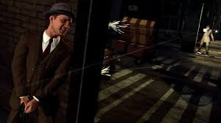

Figure 1: “L.A. Noire" by Rockstar Games

#### 2.4.2 The Invisible Hours" by Tequila Works

#### Players can tour an old estate and follow several individuals to learn the truth behind a string of connected events in this VR murder mystery narrative . Players are able to watch and listen in on character conversations in this narrative exploration game.

#### 2.4.3 "I Expect You To Die" by Schell Games

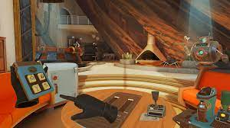

Figure 2: "I Expect You To Die" by Schell Games

#### Players take on the role of a covert agent in this VR escape game. To advance through dangerous missions, uncover a diabolical scheme, and dodge various traps and hazards, players must solve puzzles and obstacles.

#### 2.4.4 "The Vanishing of Ethan Carter" by The Astronauts

#### Players can put themselves in the shoes of a paranormal investigator in this atmospheric mystery game. In order to solve riddles and learn the truth about the disappearance of a young kid named Ethan Carter, players must first explore a rich and incredible open environment.

#### 2.4.5 "Sherlock Holmes: The Devil's Daughter" by Frogwares

Players assume the role of famous detective Sherlock Holmes in this game. In order to solve mysteries, players look into complicated cases, examine crime scenes, question suspects, and utilize logical reasoning. The gameplay in this game combines exploration, puzzle-solving, and story-driven gameplay.

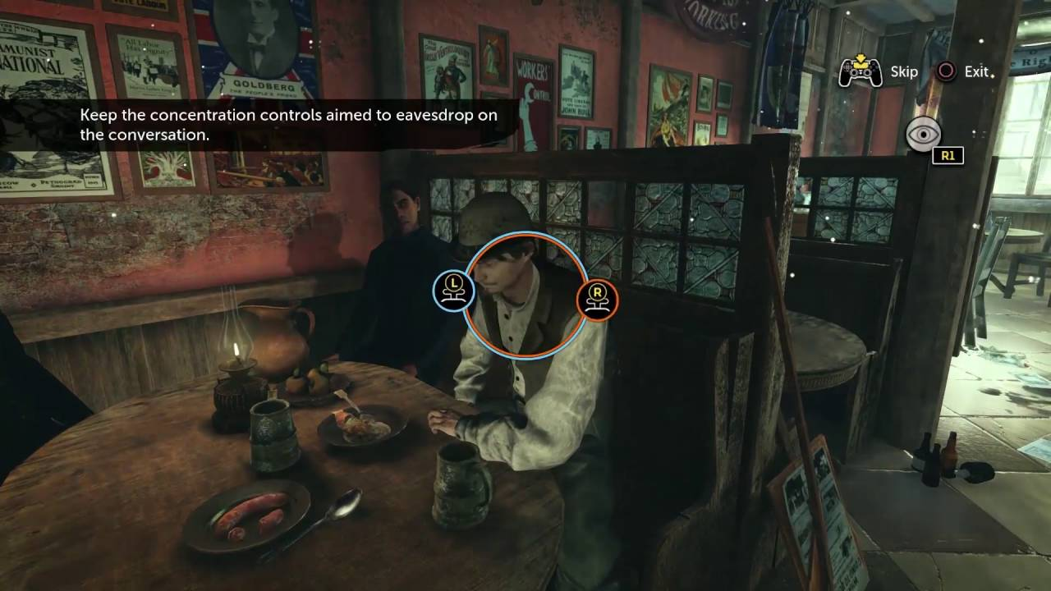

Figure 3: "Sherlock Holmes: The Devil's Daughter" by Frogwares

#### 2.4.6 Batman: Arkham VR

Players explore Gotham City as Batman to find out who killed Nightwing in this virtual reality game. By investigating crime scenes, reconsidering the evidence, and employing Batman's tools, players investigate crimes using VR technology. An authentic experience in the famous Batman universe is offered by the game.

These similar applications provide inspiration and reference for the development of the VR-based detective game. They showcase different approaches to gameplay mechanics, storytelling techniques, and immersive environments in the detective genre.

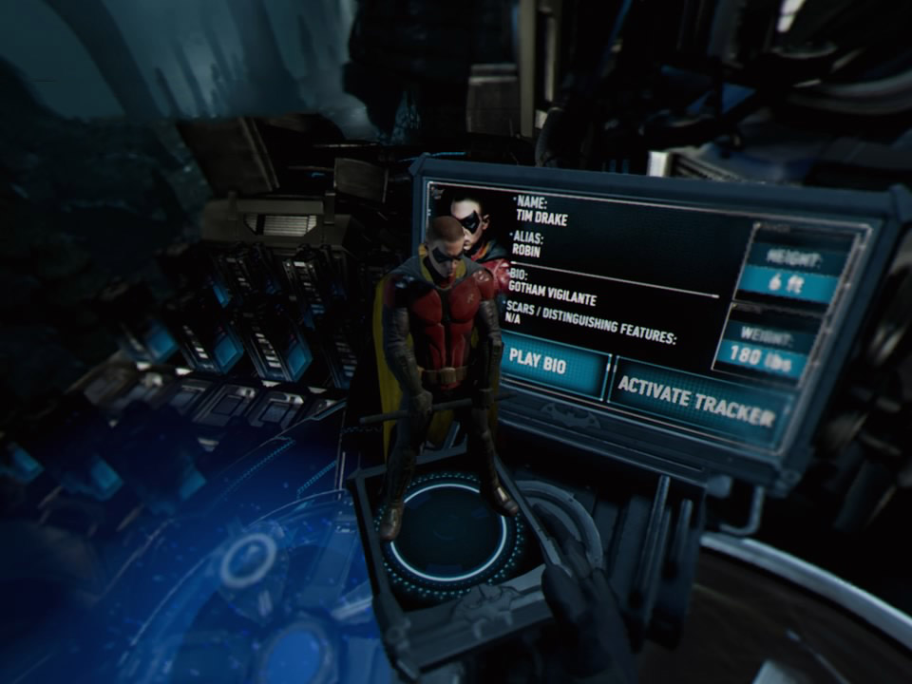

Figure 4:Batman: Arkham VR

### 2.5 Advantages and Disadvantages with similar games?

Our detective game is more realistic and interactive than other detective games because it uses VR technology and artificial intelligence. The artificial intelligence function helps players make decisions and influences various outcomes, enhancing the game's excitement and difficulty. VR technology does, however, necessitate the use of specialist equipment, which can be a drawback. Furthermore, it may take more time and effort during the development process to accurately apply artificial intelligence.

We intend to cater to consumers of various levels with the application we are developing. Our curriculum will be created with VR game platform assistance.The program will eventually be made available for free and possibly posted to the Epic Games Store or Steam. [7], [9].

# CHAPTER 3

## Software Requirements Specification

### 3.1 Introduction

**3.1.1.Background**

Our game is a VR-based detective game that seeks to provide players a compelling and immersive experience. Players step inside the shoes of the character of a detective entrusted with cracking numerous criminal cases in a city plagued by crime. The game's research, puzzle-solving, and decision-making components work together to produce an engaging and immersive gameplay experience.

**3.1.2 Objectives**

Our game's goals are to give players a lifelike and engaging detective experience in a virtual setting. Our goal is to develop a demanding gameplay that keeps players interested and delighted while testing their ability to think critically and solve problems. Players will be able to unravel puzzles, acquire information, question suspects, and finally solve crimes in the game's numerous cases, each with its own distinctive storyline.

**3.1.3 Stakeholders**

The game production team, the intended audience (players), and any potential investors or sponsors are all stakeholders in our game. Designers, programmers, artists, and other people involved in the game's creation make up the development team. The target market mostly consists of VR gaming enthusiasts and fans of games with a detective theme.

In this SRS part, we will explain technical details about Detective Game Created Using VR Technology considering it scores features, user requirements and system requirements.

#### 3.1.1 Purpose

The main purposes of our game are as follows:

**3.1.1.1 Entertainment**

Our game's main goal is to give gamers an engaging and interesting experience. We hope to engage the gamers and provide them with a pleasurable and engaging gaming experience through interesting gameplay, intriguing storylines, and interactive components.

**3.1.1.2 Education and Training**

By giving players a platform to develop and practice their problem-solving, critical thinking, and deductive reasoning abilities, our game also has an educational component. The game provides a chance for players to practice and hone their cognitive skills by replicating crime scene investigations and testing them with riddles and mysteries.

**3.1.1.3 Virtual Reality Exploration**

Utilizing VR technology to deliver a uniqe and immersive gaming experience is another goal of our game. Players can feel completely involved in the virtual environment by wearing VR headsets, which improves their sensation of presence and involvement in the game world.



Figure 5: Virtual Reality Exploration

**3.1.1.4 Skill Development**

The game aims to promote the growth of a variety of abilities, including logical thinking, analysis, observation, and decision-making skills. The game promotes the growth and use of these abilities by giving players difficult scenarios and pushing them to acquire information, examine clues, and come to wise judgments.

**3.1.1.5 Engagement and Replayability**

With different cases, branching stories, and multiple results depending on the player's decisions and actions, our game is made to be highly replayable. In order to increase the game's overall longevity and worth, it is intended to keep players interested and urge them to try new things.

#### The SRS's objective section outlines the goals that drove the creation of our game in straightforward terms. It illustrates the main goals, such as engagement, education and training, VR exploration, and skill development. We may direct the development process and make sure the game is in line with the desired goals and expectations by defining a clear purpose.

#### 3.1.2 Intended Audience and Reading Suggestions

The intended audience for the software requirements specification (SRS) document includes the development team, project stakeholders, quality assurance/testers, and management/decision-makers. The development team needs guidance on the project's scope and objectives, while stakeholders require a comprehensive understanding for informed decision-making. Quality assurance/testers rely on the document to ensure the game meets quality standards, and management/decision-makers need to align their decisions with the project's goals.

Reading "Software Requirements" by Karl Wiegers and Joy Beatty on requirements engineering, Tracy Fullerton's "Game Design Workshop" on game design principles, Unity's online documentation and tutorials on learning game development with Unity, and participating in game development communities and forums for insightful discussions are all recommended to improve understanding.

In summary, the SRS is aimed at the development team, stakeholders, QA testers, and management/decision-makers. Books on software requirements and game design, Unity's documentation and tutorials, as well as game development networks and forums are all suggested resources for further learning.

#### 3.1.3 Product Scope

The product scope for our game includes the following:

**3.1.3.1 Game Concept**

In our virtual reality (VR) detective game, players investigate crimes scenes while assuming the role of a detective. The primary goal of the game is to provide players a fully immersive and authentic experience when they investigate crimes and gather evidence.

**3.1.3.2 Virtual Crime Scenes**

Players can investigate a variety of fictitious crime scenes in the game. Each murder scene will be painstakingly created, including diverse features like rooms, items, and interactive aspects, to closely mirror real-world occurrences.

**3.1.3.3 Evidence Collection and Analysis**

Players will be able to interact with virtual world elements to gather evidence. They have the ability to look at things, take pictures, collect fingerprints, and carry out various types of investigations. The player's inventory will hold the gathered data for future study.

**3.1.3.4 Clue Analysis and Deduction**

Players can reason gathered information, connect clues, and draw potential conclusions or suspects using the game's mechanics and features. In order to proceed through the game and answer the puzzles, players must think like a deductive.

**3.1.3.5 Gameplay Progression**

There will be numerous cases or riddles to solve throughout the game's developing storyline. A sense of progression and escalating difficulty is provided as new challenges and more difficult investigations are unlocked as cases are successfully solved.

**3.1.3.6 Realistic Interactions and Environments**

The game aims to provide a high level of realism in terms of physics, object interactions, and character movements. The use of virtual reality technology will be made to provide an immersive setting where players can realistically investigate crime scenes and interact with artifacts.

**3.1.3.7 AI-driven Suspect Identification**

Artificial intelligence algorithms will be used by the game to assess the gathered evidence and offer recommendations or identify prospective suspects depending on the information at hand. This feature will enhance the challenge and provide an additional layer of complexity to the gameplay.

**3.1.3.8 Platform and Hardware**

Utilizing the Unity game engine, the game will be compatible with VR headsets including the Oculus Rift, HTC Vive, and PlayStation VR. On these platforms, the game will be developed for optimum performance and an immersive experience.

The product scope is focused on delivering an engaging and immersive VR detective game experience, where players can dive into the world of crime scene investigation, gather evidence, analyze clues, and solve mysteries. The game uses virtual reality technology and AI-driven mechanics to create a realistic and dynamic gameplay environment that will improve the entire gaming experience.

### 3.1.4 References

Some of the utilities we use to develop the application are presented below. Some software tools and systems that can be used to develop such systems are explained.

#### 3.1.4.1 Programming Languages

##### 3.1.4.1.1 What is VR (Virtual Reality) ?

##### A VR (Virtual Reality) headset is a device that gives the user the impression that they are physically present in an environment that has been created by a computer. A set of goggles or a headset with an integrated screen, sensors to track head and body movement, and occasionally built-in speakers or headphones for music make up the typical components. By wearing a VR headset, the user can enter a 360-degree virtual world where they can interact with objects, characters, and other setting elements in real time.

##### 3.1.4.1.**2 What is Unity?**

In order to create video games and simulations for PCs, consoles, and mobile devices, Unity Technologies created a cross-platform game engine. It offers a number of tools and resources for producing 2D and 3D games and supports a wide range of programming languages, including C#, JavaScript, and Boo. [1] [2]

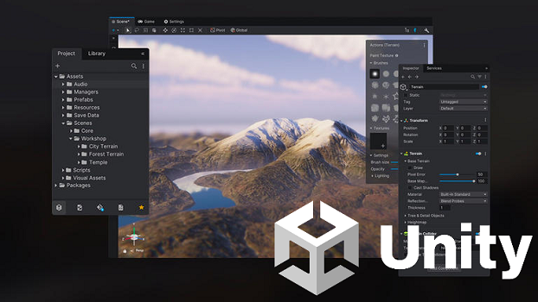

Figure 6:Screetshot fom Unity

##### Developers can create and alter game objects, sceneries, and assets using Unity's visual editor, and they can design complicated interactions and behaviors for their games using the physics engine and scripting system. Additionally, Unity offers capabilities including support for virtual reality, multiplayer networking, and in-app purchases and adverts for revenue generation.

##### 3.1.4.1.**3 What is** C Sharp(C#)?

As part of the.NET strategy, Microsoft created the contemporary object-oriented programming language C# (pronounced "C sharp"). Since its initial release in 2000 as a component of the Visual Studio.NET IDE, it has gained popularity for use in creating a variety of applications, including desktop and web applications, mobile apps, and games.

The syntax of C# is comparable to those of other well-known programming languages like Java and C++, and it is made to be simple to learn and use. It has a wide variety of language structures, including as support for generics, asynchronous programming, and object-oriented programming. It is a strongly typed language, each variable must be defined with a particular data type as well. [4]

C# is frequently used to create corporate applications and database-driven applications in addition to being heavily used in the development of Windows, web, and gaming software. It is continually adding new features and getting better thanks to the backing of a sizable and active developer community.

##### 3.1.4.1.4 What is Blender?

Blender is the free and open source 3D creation suite. It supports the entirety of the 3D pipeline—modeling, rigging, animation, simulation, rendering, compositing and motion tracking, even video editing and game creation. Advanced users employ Blender’s API for Python scripting to customize the application and write specialized tools; often these are included in Blender’s future releases. Blender is well suited to individuals and small studios who benefit from its unified pipeline and responsive development process. Examples from many Blender-based projects are available in the [showcase](http://www.blender.org/features/).

Blender is cross-platform and runs equally well on Linux, Windows, and Macintosh computers. Its interface uses OpenGL to provide a consistent experience. To confirm specific compatibility, the list of [supported platforms](https://www.blender.org/download/requirements/) indicates those regularly tested by the development team.

As a community-driven project under the [GNU General Public License (GPL)](http://www.blender.org/about/license/), the public is empowered to make small and large changes to the code base, which leads to new features, responsive bug fixes, and better usability. Blender has no price tag, but you can [invest](http://www.blender.org/foundation/donation-payment/), [participate](http://www.blender.org/get-involved/), and help to advance a powerful collaborative tool: Blender is your own 3D software.

#### 3.1.4.2 Libraries

Following libraries will be used in the current project.

##### 3.1.4.2.1 Unity Engine

##### These Unity fundamentals—creating game objects, moving them around, and handling collisions—are included in this module.

##### 3.1.4.2.2 UI Elements

##### In Unity, this library is used to build user interfaces (UI), such as scoreboards and health bars.

##### 3.1.4.2.3 Cinemachine:

##### This library is used in Unity to control camera motions and animations, which enhances the realism of the game and gives players a better viewpoint.

##### 3.1.4.2.4 Post Processing:

##### This package is used for producing realism in Unity's lighting and effects, which improves the game's ambiance and so the user experience.

##### 3.1.4.2.5 FMOD Studio:

##### This library is used in Unity for producing and manage sound effects, which improves the player’s auditory experience and gives the game a more realistic feel by it.

##### 3.1.4.2.6 ProBuilder:

##### This library allows the construction of specific environments and objects by allowing users to generate and edit 3D models in Unity.

##### 3.1.4.2.7 Amplify Shader Editor:

##### This package is used for building customized shaders in Unity, giving the game a unique appearance.

##### 3.1.4.2.8 TextMeshPro:

##### This library is used for creating and editing text elements in Unity, improving the game's storytelling or creating a better user interface.

##### 3.1.4.2.9 Behavior Designer:

##### This library is used to create artificial intelligence behaviors in Unity, enabling the creation of smart behaviors for non player charactera such as enemies or other characters.

##### 3.1.4.2.10 Odin Inspector:

This library is used for creating customized editors in Unity, speeding up the development process and creating a better user interface.

There are many libraries and APIs available for Unity, C#, and VR Technologies as well. The paragraph provides examples of some popular libraries that can be used in a project, such as SteamVR, Oculus SDK, Google VR SDK, VRTK, NewtonVR, and VR Standard Assets.

#### 3.1.4.3 Algortithms

##### 3.1.4.3.1Artificial Intelligence Algorithms:

##### The movements and other aspects of a character can be managed using these algorithms. To control a character's behavior in a game, for instance, decision trees, genetic algorithms, or deep learning strategies can be employed.

##### 3.1.4.3.2 Mapping Algorithms:

##### The gaming space can be made simpler for the player to maneuver through by utilizing the mapping methods that we apply in our project. The A* search method or the Dijkstra algorithm, for instance, can assist the character in discovering the quickest route to a particular objective.

##### 3.1.4.3.3.Data Structures:

##### The game's data can be managed and organized using a variety of data structures. For storing game items, characters, or other elements, you could utilize linked lists, queues, stacks, and trees.

##### 3.1.4.3.4 Physics Engines:

The physics engine that comes with Unity can be used to simulate how in-game objects move. The management of gravitational effects, collisions, and other physical characteristics of objects can be done with this engine.

##### 3.1.4.3.5 Animation Engines:

##### Character animations can be controlled using an animation engine.

##### Our project might be a good fit for the built-in animation engine in Unity or other animation engines (like Mecanim or Spine).

##### 3.1.4.3.6 Game Engine Optimization:

##### The performance of the game engine can be tracked and enhanced using Unity's built-in profiling tools or third-party tools (such as Visual Studio Profiler or Unity Performance Profiler).

##### 3.1.4.3.7 3D-Modeling and Animation Software:

##### Character and object design and animation can be facilitated by the 3D modeling and animation tools we utilize in our project. For 3D modeling and animation, some popular programs are Blender, Maya, and 3DS Max.

##### 3.1.4.3.8 Voice assistant:

Within the game, we'll utilize a voice assistant to give hints or plot points. For instance, a voice assistant giving players information about a witness can enhance the game's narrative.

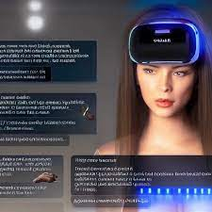

Figure 7:Vooice Assistant on VR game

##### 3.1.4.3.9 Recognition of expressions:

Artificial intelligence techniques will be used to recognize player inputs including voice commands and facial expressions. For instance, characters may be able to carry out particular activities thanks to an algorithm that recognizes player expressions or voice orders.

### 3.2 Specific Requirements

The requirements section has split into two main parts: user requirements and system requirements.

#### 3.2.1 User Requirements

These requirements are written for the customers, it’s written in a simple and natural language that does not contain details. The purpose of this requirement is to allow customers to ensure that the system will perform as expected, it’s also a form of communication between the developers and the customers.

##### 3.2.1.1 Immersive Gameplay

Users demand environments that are realistic and bring them into the world of crime scene investigation.

##### In order to give players a sense of presence and let them engage with the virtual world, the game should make advantage of VR technology.

##### 3.2.1.2 Intuitive Controls

Users need controls that are simple to use and intuitive so they can engage and navigate the virtual environment with ease.

Controls must work with the particular VR device being utilized, ensuring a cozy and immersive experience.

##### 3.2.1.3 Engaging Storyline

##### Users want a fascinating narrative with well-developed characters, exciting riddles, and surprising plot twists.

##### The story should develop gradually to keep users interested and inspired to solve the crimes and learn the truth.

##### 3.2.1.4 Challenging Puzzles and Investigations

Users may anticipate a wide range of difficult investigations, riddles, and decision-making situations that will put their deductive reasoning and investigative skills to the test.

##### To keep players interested and engaged, the game should have a balanced difficulty curve that gradually increases the complexity of the obstacles.

##### 3.2.1.5 Realistic Environments and Visuals

Users value realistic object interactions, finely detailed crime scene surroundings, and high-quality graphics.

##### To create an immersive environment and improve the overall detective experience, the audiovisual components should be thoughtfully designed.

##### 3.2.1.6 Multiple Outcomes and Branching Paths

Users enjoy games that let them choose between different results and diverging paths based on their choices and behaviors.

##### Users should be able to affect the plot and discover various outcomes by making decisions in the game that have effects.

##### 3.2.1.7 Training and Tutorial Support

For users to comprehend the game mechanics, controls, and investigative tactics, there may need to be clear instructions, tutorials, or training modes.

##### To help players become accustomed to the gameplay, the game should offer sufficient instructions and support, especially at the beginning.

##### 3.2.1.8 Compatibility and Accessibility

Users anticipate that the game will work with a variety of VR hardware platforms, ensuring accessibility and versatility.

Additionally, the game should think about accessibility elements like a scalable difficulty setting, control options for players of varying abilities, and visual and audio customization

### 3.2.2 System Requirements

System Requirements for the VR-Based Detective Game:

#### 3.2.2.1 Hardware Requirements

**Compatible VR Headset:** The game requires a VR headset compatible with the platform being used, such as Oculus Rift, HTC Vive, or PlayStation VR.

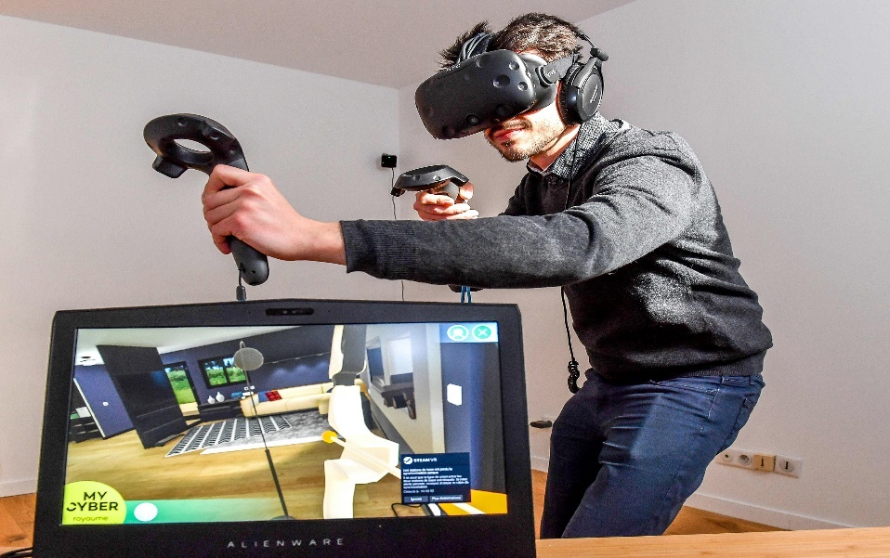

Figure 8: Compatible VR Headset

**Minimum System Specifications:** The game may specify the minimum hardware requirements, including the processor, RAM, and graphics card, to ensure smooth performance and optimal VR experience.

#### 3.2.2.2 Software Requirements

**VR Platform:** The game should specify the required VR platform, such as SteamVR or Oculus Home, and any additional software or drivers needed for the VR headset to function properly.

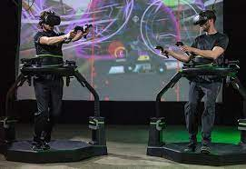

Figure 9: VR Platform

**Operating System:** Specific operating systems, like Windows, macOS, or PlayStation, should be supported by the game.

#### 3.2.2.3 Input and Controls

**VR Controllers:** The game should support the VR controllers associated with the chosen VR headset, allowing players to interact with the virtual environment and perform actions.

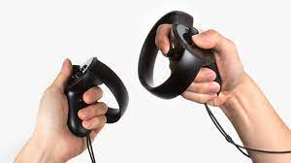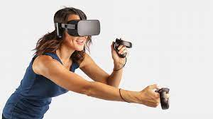

Figure 10: VR Controllers

**Keyboard and Mouse (Optional):** If the game supports non-VR modes or additional control options, it may require keyboard and mouse input for certain functions.

#### 3.2.2.4 Storage Requirements

**Disk Space:** The quantity of disk space needed for installation and storage of game components, levels, and save files should be specified by the game.

#### 3.2.2.5 Graphics and Performance

**Rendering Quality:** For the best visual experience, the game should specify the suggested graphics settings and rendering quality.

**Frame Rate:** To avoid motion sickness and make the VR experience enjoyable, the game should aim for a steady frame rate.

### 3.2.3 Functional Requriments

Functional requirements in applications are the part where we specify what should be done functionally. In games, there are many important factors such as gameplay, mechanics, in-game interactions.

#### 3.2.3.1 Controls and Playability

#### It discusses the specifications for how the player will operate the vehicle or character, the features that can be accessed using keyboards or gaming controllers, and how the game is played.

#### 3.2.3.2 Game Mechanics

Basics such as jumping, running, fighting, solving puzzles, strategizing specifies the requirements of the features.

#### 3.2.3.3 Objectives and Missions:

Requirements for completing particular objectives, missions, or activities in the game. This instructs players on what to do, how to advance, or how to accomplish particular objectives.

#### 3.2.3.4 Sound and Visual Effects:

The requirements for sounds, music, dialogues and visual effects in the game are specified to create the atmosphere and enhance the experience of the players.

#### 3.2.3.5 VR:

This is the part where VR requirements are used. How to interact with VR and use it in the game.

VR is required for interacting with environment as shown in *Figure 14 .*

### 3.2.4 Non Functional Requirements

#### 3.2.4.1 Performance

#### The performance and frame rate of the game are ideal for a fluid gaming experience. Performance relates to how quickly, responsively, and effectively the system uses its resources. It is an important component of software systems.

#### 3.2.4 .2 High-quality Audio System

The game must feature a top-notch audio setup that gives the player feedback and improves the mood.A software system should have a good audio system, especially for sound-intensive applications like games, multimedia programs, music players, and voice-based user interfaces.

#### 3.2.4.3 User Interface

#### The game's user interface needs to be well-designed, user-friendly. The user interface (UI) is how users communicate with software programs and apps. It has every interactive and visual element designed to facilitate user input, output, and navigation.

#### 3.2.4.4 High-quality Graphics

High-quality graphics is a desirable characteristic of a software system, particularly in applications that involve visual elements such as video games, simulations, or graphic-intensive applications. The game must be visually appealing and have high-quality graphics that are suitable for a VR game.

#### 3.2.4.5 Compatibility

To enhance accessibility, the game must be compatible with a variety of VR headset models.In order for a software system to function efficiently and without interruption in its intended environment, including hardware, software, and other systems or components, it must be compatible.

### 3.2.5 Software System Attributes

This section will introduce non-functional attributes

#### 3.2.5.1 Reliability

#### A key component of our VR criminal game idea is dependability. It's crucial to make sure the game is reliable and doesn't crash or have any other technical problems that can have an impact on how fun it is to play. To do this, we will put the game through a thorough testing process to make sure it can handle a variety of scenarios, user inputs, and hardware setups.

#### 3.2.5.2 Maintainability

Maintainability is also important since our game is intended for use in police schools for training purposes. The game needs to be made in a way that makes it simple to update and maintain. We'll use a modular architecture to accomplish this because it makes upgrades, bug fixes, and enhancements simple. Version control tools will also be used to keep track of modifications made to the game's assets and code.

#### 3.2.5.3 Efficiency

Efficiency is still another important factor. We want the game to perform well and provide a smooth user experience. To achieve this, we will optimize it for performance by using efficient algorithms and data structures. Additionally, we shall avoid from resource-intensive processes and take into account employing hardware-accelerated rendering methods.

#### 3.2.5.4 Usability

Usability is also important, especially since some users may not be familiar with VR technology. The game should be simple to use and navigate. We'll make sure the user interface is simple to use and intuitive to accomplish this. By performing user testing and soliciting input from prospective users, we'll also make sure that the game's mechanics are simple to understand.

#### 3.2.5.5 Technology

The use of technology is necessary to create a top-notch VR game. To succeed, we must have access to the most recent VR hardware and software tools. We must also have the technical skills and expertise to use this technology effectively.

#### 3.2.5.6 Finance

Finance is a critical consideration as well. For the project, we must create a realistic budget that accounts for the expenditures of the hardware, software, development, testing, and marketing.We may also consider alternative sources of funding, such as grants, sponsorships, or crowdfunding.

Financialcalculations of our main method in *Table 10.*

#### 3.2.5.7 Time

Timeline that takes into account the complexity of the game, the development resources available, and the potential risks and challenges that may arise. We might think about employing project management tools to keep tabs on the situation and control deadlines.

Our time table specified in the *Table 10*

#### 3.2.5.8 Resources

The project needs resources to be finished properly. We must make sure we have all the tools we need, including the buildings, personnel, software, and hardware. If necessary, we may consider outsourcing some aspects of the project, such as art or sound design. We will design using the technology in ARBİM.

#### 3.2.5.9 Legal

Finally, legal considerations are important. All pertinent laws and rules, such as those governing copyright, intellectual property, and data protection, must be followed. We might think about getting legal counsel to make sure we'll get all the licenses and rights required to create and release the game.

Users appreciate games that offer multiple outcomes and branching paths based on their decisions and actions.

The game should provide meaningful choices that have consequences, allowing users to shape the story and experience different endings.

# CHAPTER 4

## Feasibility Study

## 

### 4.1 Introduction

The feasibility document will cover various aspects of the project, including technical feasibility, description feasibility, and financial feasibility. Technical feasibility will focus on the game's development, including the use of Unity, C#, and VR glasses. Description feasibility will explore the description for the game and the target audience. Cost and risk feasibility will cover the costs involved in developing the game and the potential revenue streams.

#### 4.1.1 Purpose of the Feasibility Report

It is crucial to save feasibility studies and achieve results. It makes the technical and economic evaluation of the project. It helps the decision makers to determine the possible burdens and to make composition decisions about investing in resources. A feasibility document includes essential information such as costs, return on investment, estimation time approaching, and potentially avoidance. It is a crucial tool for achieving a target potential before project executives commit resources to their beneficiaries and losses.

### 4.2 Project Description

A detective game called The VR Criminal Game is under development. It is made to replicate criminal trials and provide the gamer an immersive experience. Players that want to solve puzzles and look into crimes are the game's target audience. The protagonist of the game is a detective who must gather evidence and examine the crime scene in order to solve a crime.

The player must find the evidence to pinpoint the true offender among the various suspects in the game. The player will be closer to apprehending the genuine offender the more evidence they uncover. There will be a scoring system in the game that honors the player for their accomplishments, such as the quantity of evidence gathered and the length of time it took to crack the case.

This project might have a significant impact on police education schools as it serves low-cost platform for training purposes . VR technology is developing rapidly, and this game will provide a high standard of performance at an affordable price. Moreover, the game can help people with attention deficits by providing an immersive experience that can help them feel the real life experience.

Overall, the VR Criminal Game is an innovative project that has the potential to provide a unique gaming experience while also addressing important social issues.

### 4.3 Justification

Today, various disasters cause the interruption of education and make online lectures obligatory. On the other hand, incidents that have occurred can not be reenacted and crime scenes cannot be left in the same condition as when the incident occurred. Re-enacting a lived event would be more interesting and productive for students rather than memorizing theoretical information. With the educational game to be developed, it is aimed to present the most realistic experience to the students. Experience is very important in professions, but without experience, no one can fully trust himself and the possibility of making mistakes increases. Sometimes these mistakes can be costly. Such as misinterpretation of criminal events or inexperienced mistakes in a conflict. With the VR game to be developed, it is aimed to provide the users with the most realistic experience and to experience the event without being in a real crime scene and thus gain experience. In order to provide a more realistic and interesting experience, targeted training can be provided by using VR technology, which is becoming more and more widespread today. Our VR criminal game project is a great idea and has significant potential for several reasons:

**4.3.1 Training Tool**

Our game can be used by law enforcement organizations and police academies as a training resource. By mimicking criminal cases and offering a realistic experience, it can aid in the development of trainees' investigation skills. This can assist educate more officers at once while saving money on pricey real-life simulations.

**4.3.2 Attention Deficit**

It has been demonstrated that VR technology helps attention deficit disorder sufferers focus and pay attention. As users can immerse themselves in a realistic crime scene investigation and concentrate on the work at hand, our game can be an effective tool for persons with attention problems to enhance their cognitive abilities.

**4.3.3 Unique**

By incorporating VR technology into a crime scene investigation game, our concept offers a distinctive experience. Both game enthusiasts and others interested in criminal investigations will be interested in this, which could result in sales and broad use.

**4.3.4 Educational Value**

The educational potential of our VR crime game idea is clear. It can be used to inform the general public about how criminal investigations work and how crucial gathering evidence is. It can also be used to instruct students in the criminal justice system and investigative methods in schools and universities.

**4.3.5 Cost-Effective**

It is less expensive to create a VR game than a real-world platform. Additionally, the project may be finished in a fair amount of time because to the utilization of already-available technology like VR glasses, Unity, and C#. can be utilized in multiple locations at once without running out of space

In conclusion, there is a lot of promise for our VR crime game project. It can be played as an original and creative game for amusement or for training and educational reasons. It is a doable project to take on because it is affordable and makes use of ARBIM's current technologies.

### 4.4 Consideration

**4.4.1 Reliability**

A key component of our VR criminal game idea is dependability. It's essential to ensure that the game is dependable, doesn't crash, or has no other technical issues that can affect how enjoyable it is to play. To achieve this, we will thoroughly test the game to ensure that it can cope with a range of scenarios, user inputs, and machine configurations.

**4.4.2 Maintainability**

Since our game is meant to be used for instructional purposes in police academies, maintainability is particularly crucial. The game must be created in a way that makes updating and maintaining it straightforward. To do this, we'll employ a modular architecture because it makes upgrades, bug fixes, and enhancements easy. Tools for version control will be used to record changes made to the game's assets and code.

**4.4.3 Efficiency**

Efficiency is another important factor. We want players to have a satisfying experience with the game. We will use effective algorithms and data structures to improve it for performance in order to accomplish this. Additionally, we shall refrain from resource-intensive processes and take into account employing hardware-accelerated rendering methods.

**4.4.4 Usability**

Usability is crucial, particularly given that some consumers might not be familiar with VR technology. The game should be simple to use and navigate. To do this, we'll make sure the user interface is user-friendly and intuitive. We'll also make sure that the game's mechanics are easy to understand by doing user testing and asking for feedback from potential users.

**4.4.5 Technology**

The use of technology is necessary to create a top-notch VR game. We need access to the most modern VR hardware and development tools if we are to succeed. To use this technology efficiently, we must also possess the necessary technical knowledge and competence.

**4.4.6 Finance**

Another important factor is finances. We must design a realistic budget for the project that takes into consideration the costs of the hardware, software, development, testing, and marketing.Alternative funding options like grants, sponsorships, or crowdsourcing might also be taken into account.

**4.4.7 Time**

Time is another crucial element in the growth of a project. a schedule that accounts for the game's complexity, the resources available for production, and any potential risks or difficulties. To monitor the situation and manage deadlines, we can consider using project management software.

**4.4.8 Resources**

The project needs resources to be finished properly. We must make sure we have all the tools we need, including the buildings, personnel, software, and hardware. If necessary, we might think about contracting out some project components, such the visual or aural design. Utilizing ARBIM technology, we will design.

**4.4.9 Legal**

Finally, legal considerations are important. All pertinent laws and rules, such as those governing copyright, intellectual property, and data protection, must be followed. We might think about getting legal counsel to make sure we'll get all the licenses and rights required to create and release the game.

Users esteem games that offer multiple outcomes and branching paths based on their decisions and actions.

The game should provide reasoonable and logical choices that have consequences, allowing users to shape the story and experience different endings.

### 

### 4.5 Existing System and Technology

In this section, some software tools and systems that can be used to develop such systems are explained.

#### 4.5.1 Programming Languages

##### 4.5.1.1 What is VR (Virtual Reality)?

##### A VR (Virtual Reality) headset is a tool that enables the user to feel as though they are physically present within a computer-generated environment. The typical components are a set of goggles or a headset with an integrated screen, sensors for monitoring head and body movement, and occasionally built-in speakers or headphones for music. Wearing a VR headset allows the user to enter a 360-degree virtual world where they can interact in real-time with characters, objects, and other components of the setting.

##### 4.5.1.2 What is Unity?

##### For creating video games and simulations for computers, consoles, and mobile devices, Unity is a cross-platform game engine.

##### Using Unity's visual editor, developers may build and modify game assets such as scenes, characters, and objects. They can also design intricate interactions and behaviors for their games using the physics engine and scripting system. In addition, Unity provides features including support for virtual reality, multiplayer networking, in-app purchases, and advertisements for generating cash.

##### 4.5.1.3 What is C Sharp(C#)?

Microsoft developed the modern object-oriented programming language C# as part of the.NET strategy. It has grown in prominence since its first release as a part of the Visual Studio.NET IDE in 2000 for use in developing a range of applications, including desktop and web applications, mobile apps, and games.

C# was designed to simple to learn and use, and its syntax is similar to that of other well-known programming languages like Java and C++. In addition to supporting generics, asynchronous programming, and object-oriented programming, it provide a wide range of language structures. Additionally, each variable needs to be declared with a specific data type because it is a strongly typed language.

In addition to being widely utilized in the development of Windows, online, and gaming software, C# is frequently used to create business applications and database-driven applications. Thanks to the support of a huge and active development community, it keeps improving and adding new features.

##### 4.5.1.4 What is Blender?

Blender is the free and open source 3D creation suite. It supports the entirety of the 3D pipeline—modeling, rigging, animation, simulation, rendering, compositing and motion tracking, even video editing and game creation. Advanced users employ Blender’s API for Python scripting to customize the application and write specialized tools; often these are included in Blender’s future releases. Blender is well suited to individuals and small studios who benefit from its unified pipeline and responsive development process. Examples from many Blender-based projects are available in the [showcase](http://www.blender.org/features/).

Blender is cross-platform and runs equally well on Linux, Windows, and Macintosh computers. Its interface uses OpenGL to provide a consistent experience. To confirm specific compatibility, the list of [supported platforms](https://www.blender.org/download/requirements/) indicates those regularly tested by the development team.

As a community-driven project under the [General Public License (GPL)](http://www.blender.org/about/license/), the public is empowered to make small and large changes to the code base, which leads to new features, responsive bug fixes, and better usability. Blender has no price tag, but you can [invest](http://www.blender.org/foundation/donation-payment/), [participate](http://www.blender.org/get-involved/), and help to advance a powerful collaborative tool: Blender is your own 3D software.

#### 

#### 4.5.2 Libraries

Following libraries will be used in the current project.

**4.5.2.1 Unity Engine**

These Unity fundamentals—creating some game objects, moving them around, and handling collisions-are included in this module.

**4.5.2.2 U IElements**

The library is used to create user interfaces (UI) in Unity, such as health bars and scoreboards.

**4.5.2.3 Cinemachine**

This library is use for in Unity to control camera motions and animations, which enhances the realism of the game and gives players a better viewpoint

**4.5.2.4 Post Processing**

This package is used to create realistic lighting and effects in Unity, which enhances the mood and user experience of the game.

**4.5.2.5 FMOD Studio**

The use of this library in Unity enhances the players' auditory experience and provides the game a more realistic feel by creating and managing sound effects.

**4.5.2.6 ProBuilder**

This library enables users to create and modify 3D models in Unity, enabling for the creation of distinctive environments and objects.

**4.5.2.7 Amplify Shader Editor**

This package is used to build customized shaders in Unity, giving the game a distinctive appearance.

**4.5.2.8 TextMeshPro**

By using this library, text elements can be created and edited in Unity, enhancing the game's narrative or enhancing the user interface.

**4.5.2.9 Behavior Designer**

This package is used to build AI behaviors in Unity, making it possible to develop clever behaviors for antagonists or other characters.

**4.5.2.10 Odin Inspector**

In Unity, this library is used to build customized editors, which streamlines the development process and improves the user interface.

Additionally, there are a ton of libraries and APIs for C#, VR, and Unity technologies. The paragraph gives samples of some well-known libraries that can be utilized in a project, including VR Standard Assets, VRTK, NewtonVR, Oculus SDK, Google VR SDK, and SteamVR.

#### 4.5.3 Algorithms

**4.5.3.1 Artificial Intelligence Algorithms**

The movements and other aspects of a character can be managed using these algorithms. To control a character's behavior in a game, for instance, decision trees, genetic algorithms, or deep learning strategies can be employed.

**4.5.3.2 Mapping Algorithms**

The gaming space can be made simpler for the player to maneuver through by utilizing the mapping methods that we employ in our project. The A* search method or the Dijkstra algorithm, for instance, can assist the character in discovering the quickest route to a particular objective.

**4.5.3.3 Data Structures**

Various data structures can be used to organize and manage the data within the game. For example, linked lists, queues, stacks, and trees can be used to store objects, characters, or other features within the game.

**4.5.3.4 Physics Engines**

Unity's built-in physics engine can be used to simulate the movement of objects within the game. This engine can be used to manage the gravitational effects, collisions, and other physical features of objects.

**4.5.3.5Animation Engines**

Character animations can be controlled using an animation engine. Your project might be a good fit for the built-in animation engine in Unity or other animation engines (like Mecanim or Spine).

**4.5.3.6 Game Engine Optimization**

The performance of the game engine can be tracked and enhanced using Unity's built-in profiling tools or third-party tools (such as Visual Studio Profiler or Unity Performance Profiler).

**4.5.3.7 3D Modeling and Animation Software**

Character and object design and animation can be facilitated by the 3D modeling and animation tools we utilize in our project. For 3D modeling and animation, some popular programs are Blender, Maya, and 3DS Max.

**4.5.3.8 Voice assistant**

Within the game, we'll employ a voice assistant to give hints or plot points. For instance, a voice assistant giving players information about a witness can enhance the game's narrative.

**4.5.3.9 Recognition of expressions**

Artificial intelligence techniques will be used to recognize player inputs including voice commands and facial expressions. For instance, characters may be able to carry out particular activities thanks to an algorithm that recognizes player expressions or voice orders4.6 Solutions

#### 4.6.1 Method 1:

In our project our main target is to utilizing VR technology.With VR technology it is aimed to make players experience lifelike and practical gameplay.With a solid storyline players will be drawn into the game by getting their curiosity triggered. With a narrative-driven story players will be allowed to solve multiple series of connected mysteries and the game will be more playable.

Exploration game mechanics will push players to use their analythic thinking and observation skills to solve cases in the game.With dialogue and investigation trees that will implemented players will have to be more careful because different paths and outcomes will be occured depending on decisions of players.

#### 4.6.2 Method 2:

It is intended for players to experience a realistic experience stepping inside shoes of the iconic superhero Batman. VR technology was utilized to bring the realism of this experience to the next level. Immersion of the game is provided by an original story that puts the player at the center of a series of mysteries that needs to be solved using Batman's tools and using detective skills. Detailed environments and character models bring players table a realistic and credible absorbing world for the players to explore. Challenges and interactive puzzles push players to use their problem-solving skills and make them utilize Batman's tools and abilities.Action sequences that allow the players to experience the affect of being Batman in a series of intense and exciting moments provides an unique experience for players.

#### 4.6.3 Method 3:

With a provided narrative-driven story that it allows the player to solve series of connected mysteries.With a combination of puzzle solving and exploration game mechanics players are pushed to use deductive reasoning and observation skills to solve the mysteries in the game.With dialog and investigation trees players can choose and follow different paths and outcomes depends on choices and actions of players. Detailed environments and character animations immerse players.Sound design that features a moody and atmospheric soundtrack and detailed sound effects and voice acting brings the atmosphere of the game universe to players.

#### 4.6.4 Method 4:

Motion capture technology is used for capturing the movements and facial expressions of the actors portraying the characters of the game. A complex and branching narrative shaped by the player's choices and actions is occured.

Made use of Quick Time Events(QTEs) to add tension and urgency to the game's action sequences.By providing highly detailed and realistic graphics and animation for the game's world and characters it is aimed to immerse players. It is intended to provide players a more immersive experience a dynamic soundtrack and detailed sound effects voicing and advanced sound design are provided.

### 4.7 Risk and Cost Estimates

#### 4.7.1 Risk:

1. **Technical feasibility:** Technically speaking, creating a VR game can be challenging and may call for specific hardware and software. It could be difficult to make sure that our team has the resources and technological know-how required to develop the game.
2. **Time and cost:** Technically speaking, creating a VR game can be challenging and may call for specific hardware and software. It could be difficult to make sure that our team has the resources and technological know-how required to develop the game.

#### 4.7.2 Benefits:

**Tangible benefits:**

1. Generating income from game sales or in-game purchases.
2. Greater brand visibility and familiarity thanks to media attention and social media exposure.
3. Possibilities for joint ventures and collaborations with other businesses or groups.
4. Possibility of generating more money by licensing the game's intellectual property.
5. Potential for growth and expansion of the company's product offerings, resulting in increased revenue and profitability.

**Intangible benefits:**

1. Improved reputation and credibility of the company as an innovator in the VR gaming industry.
2. Increased customer engagement and brand loyalty through the development of a unique and immersive gaming experience.
3. Opportunities for professional development and growth for the development team working on the project.
4. Positive impact on the morale and motivation of the company's employees through the excitement and sense of accomplishment associated with developing a successful VR crime game.
5. Contribution to the advancement of the VR technology industry and the broader gaming industry through the development of innovative VR crime-solving gameplay mechanics and storytelling techniques

### 4.8 Risk and Cost for Detective VR Game:

The cost calculation shows us whether the project is logical or not to be put on the market. The average profit and loss calculation is made by calculating the cost calculation and the return of the program. Here, we present to you what and how much money will go to the project, where we will generate income, and we calculate whether it is safe to do this project.

**Development Cost:**

The cost for buildingthe model

**Personal:**

Table 1: Personel ,Development Cost

|  |  |  |
| --- | --- | --- |
| 2 | Game Developer (270 hours 100 lira/hours) | 54.000 lira₺₺ ₺ ₺ |
| 2 | Graphic Designer (160 hours 80 lira/hours) | 25.600 lira |
| 1 | Sound Designer (30 hours 50/hours) | 1500 lira |
| 1 | Tester (36 hours 70 lira/hours) | 2520 lira |
| 1 | Virtual Reality Expert (12 hours 100 lira/hours) | 1200 lira |
| 1 | Story Creator ( 8 hours 50$/hours) | 400 lira |

**Expenses:** ₺₺

Table 2:Expenses ,Development Cost

|  |  |  |
| --- | --- | --- |
| 1 | Promotion Videos (10videos 200 lira/per) | 2000 lira |
| 2 | Promotion Poster (5poster 70lira/per) | 350 lira |

**New Hardware & Software :**

Table 3: Development Cost

|  |  |  |
| --- | --- | --- |
| 1 | VR Set ( head and hands) | 10.000 lira |

Total Development Costs: **97.570 lira**

PROROJECTED ANNUAL OPERATING COSTS

**Personel:**

Table 4:Expenses ,Operational Cost

|  |  |  |
| --- | --- | --- |
| 1 | Programmer/Analysts (200 hours/ea 150lira/hr) | 30.000 lira |

Total Projected Annual Costs: **127.570 lira**

**Net Present Value**

**Method 1**

Table 5:Caash Flow for Method 1

|  |  |  |  |  |  |
| --- | --- | --- | --- | --- | --- |
| Cash Flow | Year 0 | Year 1 | Year 2 | Year 3 | Year 4 |
| Dev. Cost | 127.570 |  |  |  |  |
| Oper. Cost |  | 30.000 | 38.000 | 46.000 | 54.000 |
| Present Value | 1 | 0.877 | 0.769 | 0.674 | 0.692 |
| Time-adj Cost | 127.570 | 26.100 | 29.222 | 31.004 | 31.968 |
| Cumulative Cost | 127.570 | 153.670 | 182.892 | 213.896 | 245.864 |
|  |  |  |  |  |  |
| Benefits | 0 | 700.000 | 490.000 | 350.000 | 350.000 |
| T-adj Benefits | 0 | 613.900 | 104.860 | 235.900 | 207.200 |
| Comulative Benefits | 0 | 613.900 | 990.710 | 1.226.610 | 1.433.810 |
| Net Costs+Benefits | 127.570 | 486.330 | 807.818 | 1.012.714 | 1.187.946 |

**Present Value:**

1st year: 1/(1+0.14)^1 = 0.877

2st year: 1/(1+0.14)^2= 0.769

3st year: 1/(1+0.14)^3 = 0.674

4st year: 1/(1+0.14)^4 = 0.592

**Time-adj Cost:**

30.000 * 0.877 = 26.100

38.000 * 0.769 = 29.222

46.000 * 0.674 = 31.004

54.000 * 0.592 = 31.968

**Cumulative Cost:**

1st year: 127.570 + 26.100 = 153.670

2st year: 15.3670 + 29.222 = 182.892

3st year: 182.892+ 31.004 = 213.896

4st year: 213.896 + 31.968 = 245.864

**Benefit:**

1st year: We will sell 10.000 project , 100 lira for each and 30% tax for game platform = [10.000*100 - (10.000*100)% 30] = 700.000 profit

2st year: We sold 7.000 project , 100 lira for each and 30% tax for game platform = [7.000*100 - (20.000*100)% 30] = 490.000 profit

3st year: We sold 5.000 project , 10$ for each & 30% tax for game platform = [5.000 * 100 - ( 10.000*100)%30] = 350.000 profit

4st year: We sold 5.000 project , 10$ for each & 30% tax for game platform = [5.000 * 100 - ( 10.000*100)%30] = 350.000 profit

T-adj Benefits :

1st year: 700.000 x 0.877 = 613.900

2st year: 490.000 x 0.769 = 376.810

3st year: 350.000 x 0.674 = 235.900

4st year: 350.000 x 0.592 = 207.200

**Cumulative Benefits:**

1st year: 613.900

2st year: 613.900 + 376.810 = 990.710

3st year: 990.710 + 235.900 = 1.226.610

4st year: 1.226.610 + 207.200 = 1.433.810

**Net Cost Benefit:**

1st year: 613.900 - 127.570 = 486.330

2st year: 990.710 - 182.892 = 807.818

3st year: 1.226.610 - 213.896 = 1.012.714

4st year: 1.433.810 - 245.864 = 1.187.946

**Method 2**

Table 6:Cash Flow for Method 2

|  |  |  |  |  |  |
| --- | --- | --- | --- | --- | --- |
| Cash Flow | Year 0 | Year 1 | Year 2 | Year 3 | Year 4 |
| Dev. Cost | 155.400 |  |  |  |  |
| Oper. Cost |  | 35.000 | 40000 | 45000 | 50000 |
| Present Value | 1 | 0.909 | 0.826 | 0.751 | 0.683 |
| Time-adj Cost | 155.400 | 31.815 | 33.040 | 33.795 | 34.150 |
| Cumulative Cost | 155.400 | 187.215 | 220255 | 254.050 | 288.200 |
|  |  |  |  |  |  |
| Benefits | 0 | 840.000 | 588.000 | 320.000 | 280.000 |
| T-adj Benefits | 0 | 763.560 | 485.688 | 240.320 | 191.240 |
| Comulative Benefits | 0 | 763.560 | 1.249.248 | 1.480.956 | 1.680.808 |
| Net Costs+Benefits | 155.400 | 608.160 | 1.028.993 | 1.226.906 | 1.392.608 |

**Benefit:**

1st year: We will sell 10.000 project , 120 lira for each and 30% tax for game platform = 840.000 profit

2st year: We sold 7.000 project , 120 lira for each and 30% tax for game platform = 588.000 profit

3st year: We sold 5.000 project , 120$ for each & 30% tax for game platform = 320.000 profit

4st year: We sold 4.000 project , 120$ for each & 30% tax for game platform = 280.000 profit

**Method 3**

Table 7:Cash Flow for Method 3

|  |  |  |  |  |  |
| --- | --- | --- | --- | --- | --- |
| Cash Flow | Year 0 | Year 1 | Year 2 | Year 3 | Year 4 |
| Dev. Cost | 144.500 |  |  |  |  |
| Oper. Cost |  | 30.000 | 34.000 | 38.000 | 42.000 |
| Present Value | 1 | 0.884 | 0.783 | 0.693 | 0.613 |
| Time-adj Cost | 144.500 | 23.229 | 27.796 | 32.023 | 36.007 |
| Cumulative Cost | 144.500 | 167.729 | 195.495 | 227.518 | 263.525 |
|  |  |  |  |  |  |
| Benefits | 0 | 770.000 | 616.000 | 385.000 | 231.000 |
| T-adj Benefits | 0 | 680.680 | 482.328 | 266.805 | 141.603 |
| Comulative Benefits | 0 | 680.680 | 1.163.008 | 1.429.813 | 1.571.416 |
| Net Costs+Benefits | 144.500 | 512.951 | 967.513 | 1.202.295 | 1.307.891 |

**Benefit:**

1st year: We sold 10.000 project , 110 for each and 30% tax for game = 770.000 profit

2st year: We sold 8.000 project , 110 for each and 30% tax for game platform = 616.000 profit

3st year: We sold 5.000 project , 110 for each & 30% tax for game platform = 385.000 profit

4st year: We sold 3.000 project , 110 for each & 30% tax for game platform = 231.000 profit

**Method 4**

Table 8:Cash Flow for Method 4

|  |  |  |  |  |  |
| --- | --- | --- | --- | --- | --- |
| Cash Flow | Year 0 | Year 1 | Year 2 | Year 3 | Year 4 |
| Dev. Cost | 185.200 |  |  |  |  |
| Oper. Cost |  | 50.000 | 55.000 | 60.000 | 65.000 |
| Present Value | 1 | 0.909 | 0.826 | 0.751 | 0.683 |
| Time-adj Cost | 185.200 | 45.450 | 45.430 | 45060 | 44395 |
| Cumulative Cost | 185.200 | 230.650 | 276.080 | 321.140 | 365.535 |
|  |  |  |  |  |  |
| Benefits | 0 | 525.000 | 350.000 | 175.000 | 175.000 |
| T-adj Benefits | 0 | 477.225 | 289.100 | 131.425 | 119.525 |
| Comulative Benefits | 0 | 477.225 | 766.325 | 897.750 | 1.017.275 |
| Net Costs+Benefits | 185.200 | 246.575 | 490.245 | 576.610 | 651.740 |

**Benefit:**

1st year: We sold 15.000 project , 50 lira for each and 30% tax for game platform = 525.000 profit

2st year: We sold 10.000 project , 50 lira for each and 30% tax for game platform = 350.000 profit

3st year: We sold 5.000 project , 50 lira for each & 30% tax for game platform = 175000 profit

4st year: We sold 5.000 project , 50 lira for each & 30% tax for game platform = 175000 profit

### 4.9 Comparison of Solutions

Table 9:Tablo of Comparison of Solutions

|  |  |  |  |  |  |
| --- | --- | --- | --- | --- | --- |
| Feasibility criteria | Wt. | Method 1 | Method 2 | Method 3 | Method 4 |
| **1.Immersiveness**  Game should be immersive, not boring the player  **2**.**Flawlessness**  The program should work correctly, be free of bugs and errors  **3**.**Realism**  The program should not be too extreme. It should be close to realism  **4.Fluency**.  The program must flow so that there is realism | %30 | In our project our main target is to utilizing VR technology.With VR technology it is  aimed to make players experience lifelike and practical gameplay.With a solid storyline  players will be drawn into the game by getting their curiosity triggered. With a  narrative-driven story players will be allowed to solve multiple series of connected  mysteries and the game will be more playable.  Exploration game mechanics will push players to use their analythic thinking and observation  skills to solve cases in the game.With dialogue and investigation trees that will implemented  players will have to be more careful because different paths and outcomes will be  occured depending on decisions of players.  Score : 90 | (The methods used in the Batman Arkham VR)  It is intended for players to experience a realistic experience stepping inside shoes of the iconic superhero Batman. VR technology was utilized to bring the realism of this experience to the next level. Immersion of the game is provided by an original story that puts the player at the center of a series of mysteries that needs to be solved using Batman's tools and using detective skills. Detailed environments and character models bring players table a realistic and credible absorbing world for the players to explore. Challenges and interactive puzzles push players to use their problem-solving skills and make them utilize Batman's tools and abilities.Action sequences that allow the players to experience the affect of being Batman in a series of intense and exciting moments provides an unique experience for players.  Sore: 75 | (The methods used in the Sherlock)  With a provided narrative-driven story that it allows the player to solve series of connected mysteries.With a combination of puzzle solving and exploration game mechanics players are pushed to use deductive reasoning and observation skills to solve the mysteries in the game.With dialog and investigation trees players can choose and follow different paths and outcomes depends on choices and actions of players. Detailed environments and character animations immerse players.Sound design that features a moody and atmospheric soundtrack and detailed sound effects and voice acting brings the atmosphere of the game universe to players.  Score: 85 | (The methods used in Heavy Rain)  Motion capture technology is used for capturing the movements and facial expressions of the actors  portraying the characters of the game.A complex and branching narrative shaped by the player's choices  and actions is occured.Made use of Quick Time Events(QTEs) to add tension and urgency to the game's  action sequences.By providing highly detailed and realistic graphics and animation for the game's world  and characters it is aimed to immerse players. It is intended to provide players a more immersive  experience a dynamic soundtrack and detailed sound effects voicing and advanced sound design  are provided.  Score: 95 |
| **Techinical Feasibility:**  1.System must be compatible with VR  2.The SYSTEM should be optimized, the contractions should not spoil the realism. | 25% | The system works with the VR equipment we have.  Score: 80 | The system works with the VR equipment we have.  Score: 80 | The system works with the VR equipment we have.  Score : 80 | The system works with the VR equipment we have. Fluency requires a good computer processor  Score:70 |
| **Economic feasibility:**  Cost to develop:  Payback period:  (discounted)  Net present value:  Detailed calculations: | 25% | Approximately1.4 years.  1.187.946 lira  Look at method 1  Score : 90 | Approximately 1.5 years.  1.392.608 lira  Look at method 2  Score : 85 | Approximately1.5 years.  1.307.891 lira  Look at method 3  Score : 85 | Approximately.1.6 years.  651.740 lira  Look at  method 4  Score: 80 |
| **Schedule Feasibility:** | 20% | Approximately3-4 mounth  Score:95 | Approximately4-5 mounth  Score: 80 | Approximately4-5 mounth  Score: 75 | Approximately 7-8 mounth  Score : 70 |
| **Ranking:** | 100% | 88.5 | 79.75 | 82.75 | 80 |

Break event Point = 97.570/(1.187.946+97.570) = 0.0758

The payback period is approximately 1.2 years

### 4.10 Conclusions

Based on the results we have obtained, we foresee a very positive future for the VR-based detective game that we plan to develop as a graduation project. With the use of VR technology and development tools like Unity, we think we can create a fun and realistic game. It is also possible to use the game as an educational tool and can be used in police schools or similar.

# CHAPTER 5

## System Modeling

The process of constructing abstract models of a system, each of which presents a different view or perspective on that system

### 5.1 Contex Model

All external systems that will be essentially used in ours project are show in the model below. The system we are going to use are VR controller system for setting actions of user, VR headset for provide player insights from within the gave, game console for provide interaction with the game, usage database to saving data and the process of the players rendering system for in game graphics, I/O system for getting inputs From controllers, VD power sylon for making VR controllers capable to charging them up. In addition, usage databases are used so that the player can continue from where they saved.

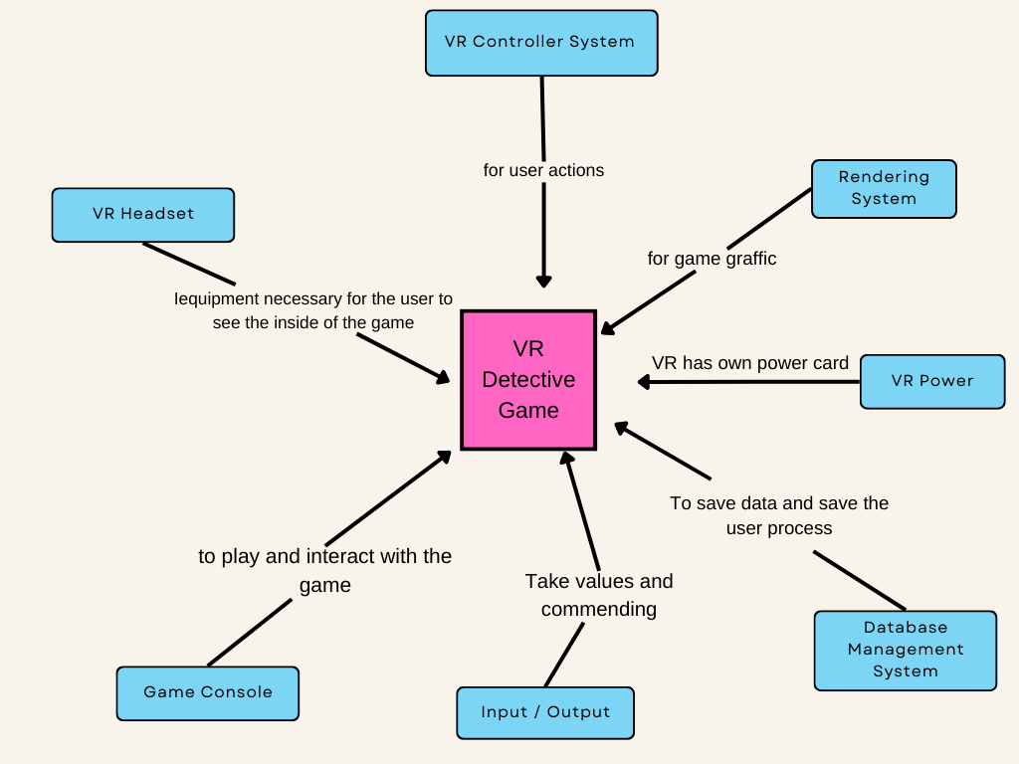

Figure 11: Context Model of VR Detective Game

### 5.2 Use Case Modeling

With this model, the relationship between the souten functions and player are exposed. Player con directly. get to game. If it's player's first time playing the game then player will be lead into tutorial section and will be able to skip tutorial and play the game if player has eager to play or registering from another computer. Player can create a new game or continue another game that was saved. Player can set the game according to his/her needs player can set the languge, effects, musto as how he/she wishes.

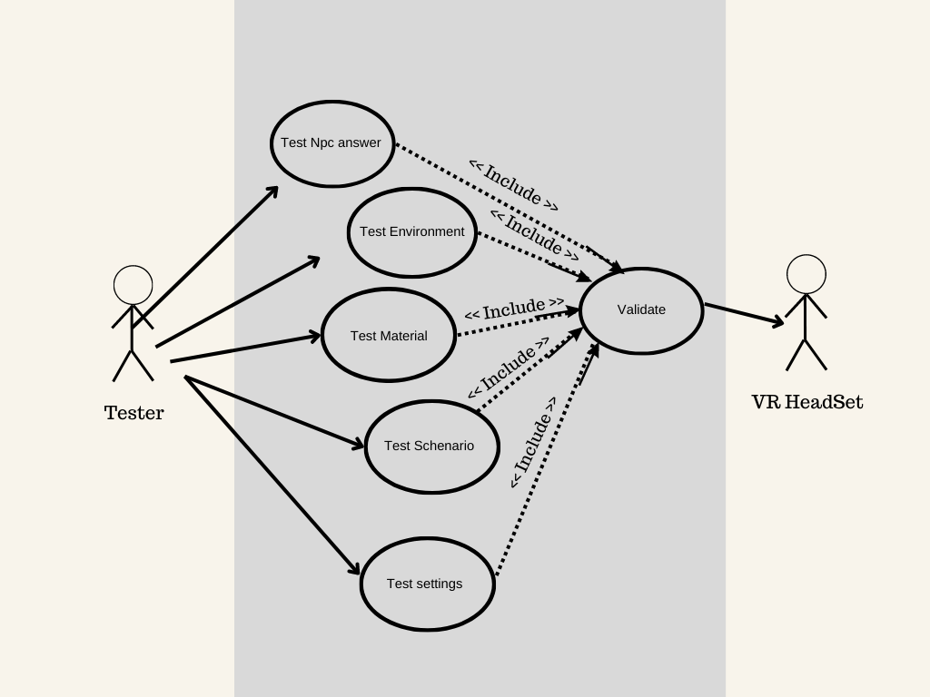

Figure 12:Tester Use Case Diagram of VR Detective Game

The tester is usually the person who checks the game for bugs. As you can see in this figure, it controls whether the materials, NPCs, dialogues, environment and events are in their own flow. It is the person who checks the game before it is released whether there are any errors anywhere and whether it works in the flow of the scenarios. If it detects an error, it notifies the admin.

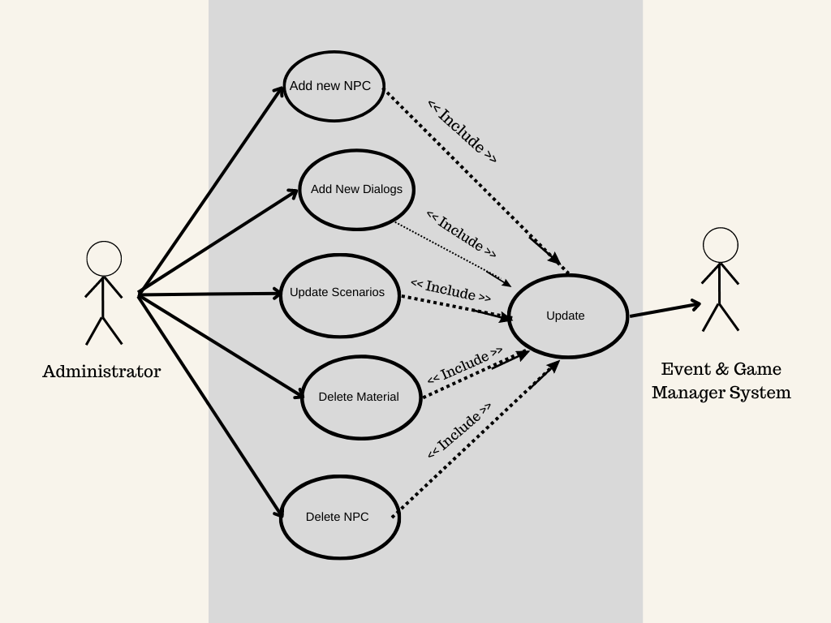

Figure 13: Admin Use Case Diagram of VR Detective Game

The admin is the person who makes the necessary changes in the game and corrects them if there are any errors. If there is an error from the tester or the players, it updates those errors. Another task is to make changes if the game needs an update, such as changing the scenario or adding or removing materials or NPCs. After making these changes, it updates and saves it to the event & manager system.

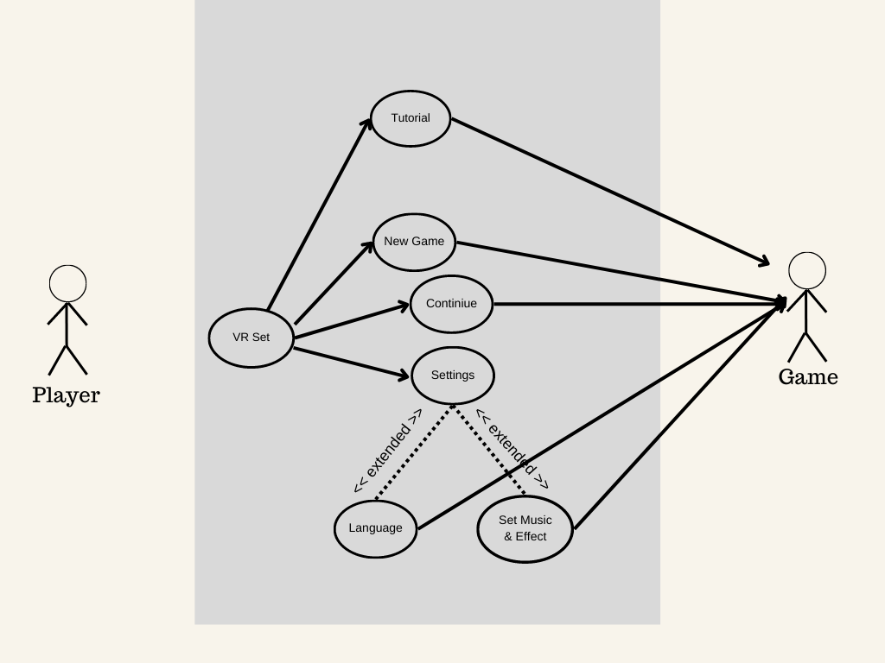

Figure 14: Player Use Case Diagram of VR Detective Game

After the tester has tested the game and the admin has updated the game, the rest is for the player to enjoy the game. Here, the player must first connect to the VR set. Afterwards, if the player has not played the game before, he can start the game with the tutorual part. If he wants to start a new game, he can choose the new game option and continue. Another option is to press continue and the player can continue from where he left off. These were the steps to enter the game. In order to change the in-game settings, you can enter the settings section and change the audio display settings or language settings.

### 5.3 Class Diagrams

#### 5.3.1 Classes and Associations

This section exposes the relationship between classes of our game. There are Solasses in our game which are:

The Player is the Character NPCs session and the Game First relationship is the player and Character relationship. Each player will have a character (detective), the character is a character for each player for appearance: Character's relationship to NPC and Criminal. There are various NPCs in the game and a few are innocent while one is guilty. Each will be contacted separately.

The other relationship is between game and session. There is a session in the game, but the scenario of the game changes according to the decisions made by the player.

Another relationship is the place in the game. This area will be the area where the player played and the area where the crime was committed. There will be various items in this area where the game takes place. Some of these items will be non-interactive, such as armchairs, lamps, fireplaces. Some will be items that give us clues and can be interacted with, such as crime gear or camera footage. These interacting tools will help us find the culprit in the game.

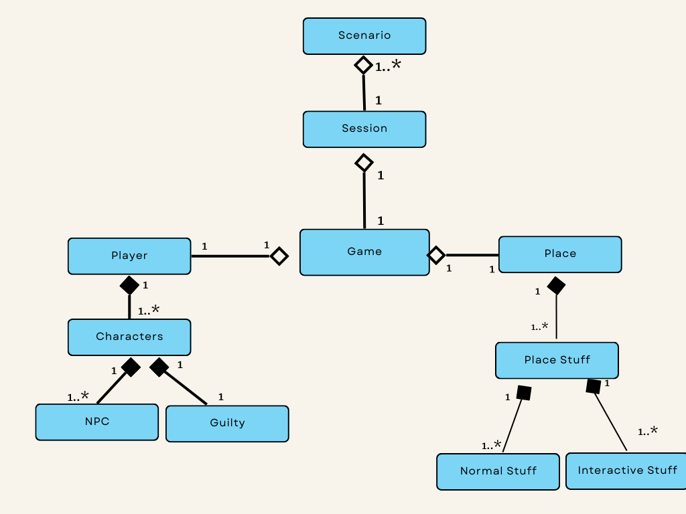

Figure 15: Classes and Associations of VR Detective Game

### 5.4 Class Diagram

In this section programming classes to be used in the project one exposed. There are six fundamental classes in our game. First is player. Player can collect items from environment that could be clues. Second is session occues various items including possible cues and items that are realy clues and can also occur eyewitness NPCs or suspecious NPCs. Thirdly NPC class. NPCs have features susch as being a witness, suspect , criminal, or irrelewant to the case. Than we have game class. Game class includes a tutorial which gives informations about how play the game or changing settings. Last class is Charachter class. This class is desically represents player in virtual world. No cosmetic changes can be made to character. Last but not least the tester session, the tester will be the person who is going to test our game and will have tester-id, tester-name and will have a specific character.

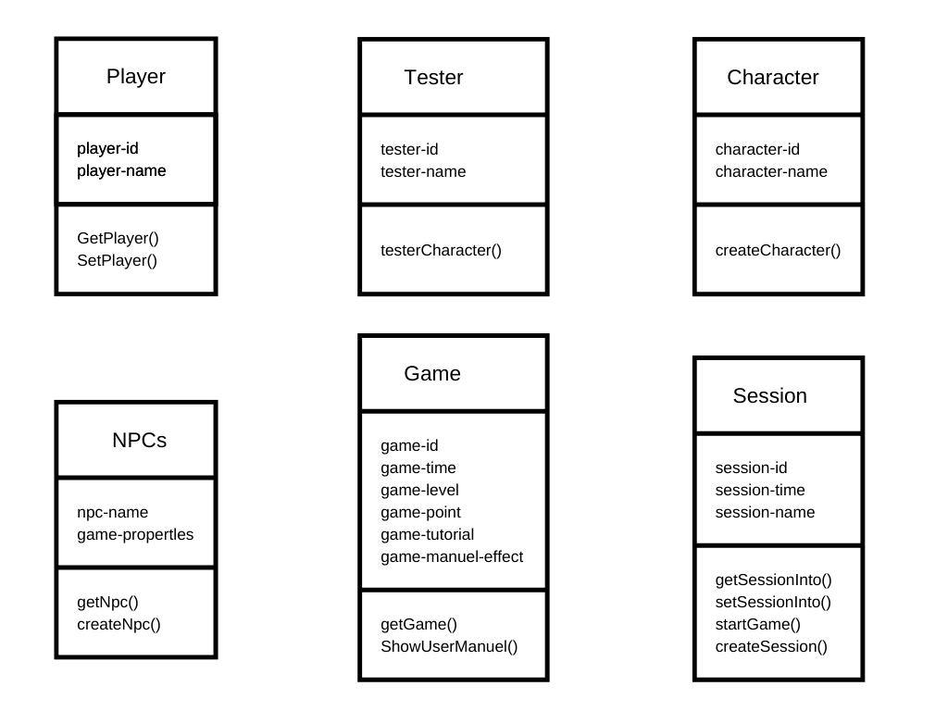

Figure 16: Class Diagram of VR Detective Game

### 5.5 Sequence Diagrams

The sequence diagram shows us how systems work according to users. In this diagram, we can see how users operate within the application. We see in the tables how the player, admin and tester will work on the processes.

The tester first connects to the VR glass and checks if it is connected. If VR glasses are connected, VR control connection is made and it is checked whether it works or not. If the VR set is running, the game is logged. Then the general structure of the game is checked, the materials are checked, the NPCs are checked and finally the scenario is checked.

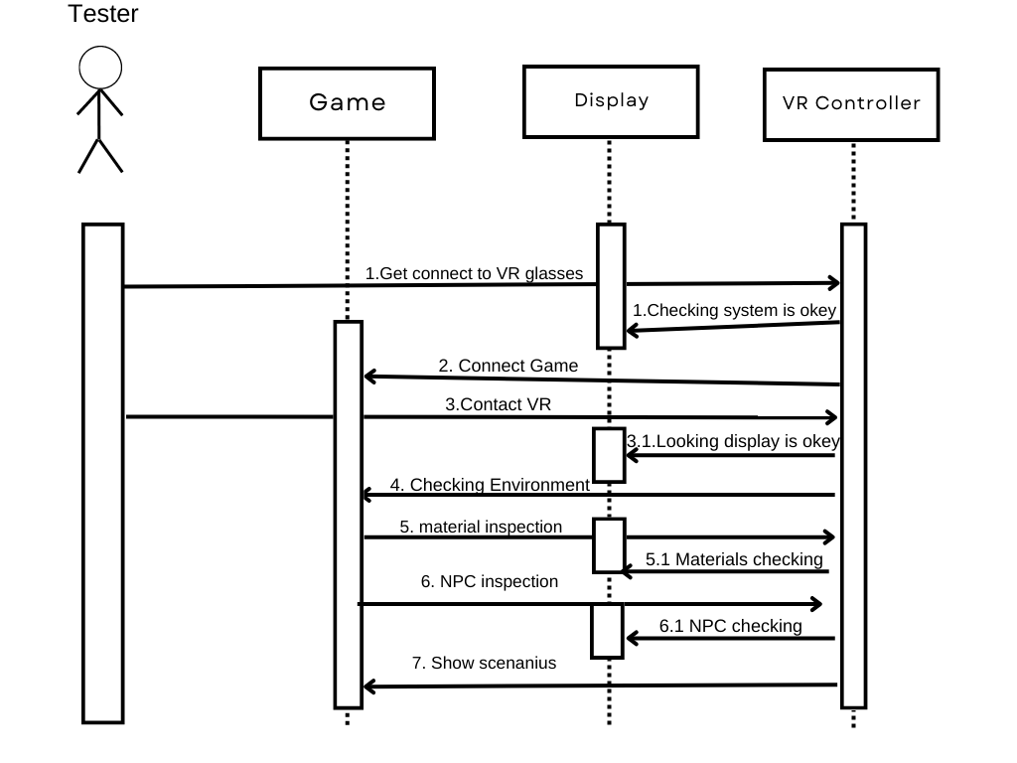

Figure 17: Tester for Sequence Diagrams of VR Detective Game

Admin is in the part that updates the game, there is no extra panel for admin. It makes the updates by entering the source codes and starts to control the updates by first connecting to the VR set and then connecting to the game. If the updates are ok it saves. It has the authority to delete and add anything from the game, for example, it can add or remove NPCs.

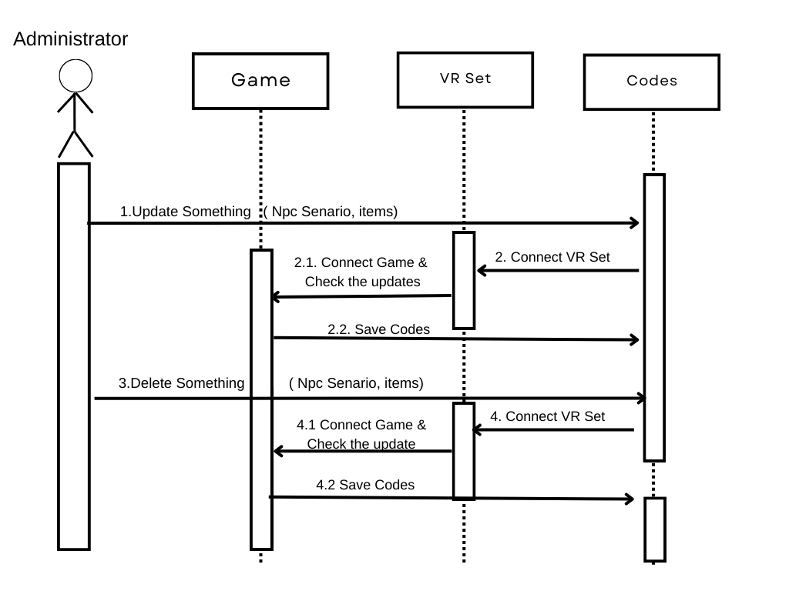

Figure 18: Administrator Person for Sequence Diagrams of VR Detective Game

The player will establish the VR connection before entering the game, and if the VR headset is running, he will look at the controls of the VR set. Then he can enter the game and play.

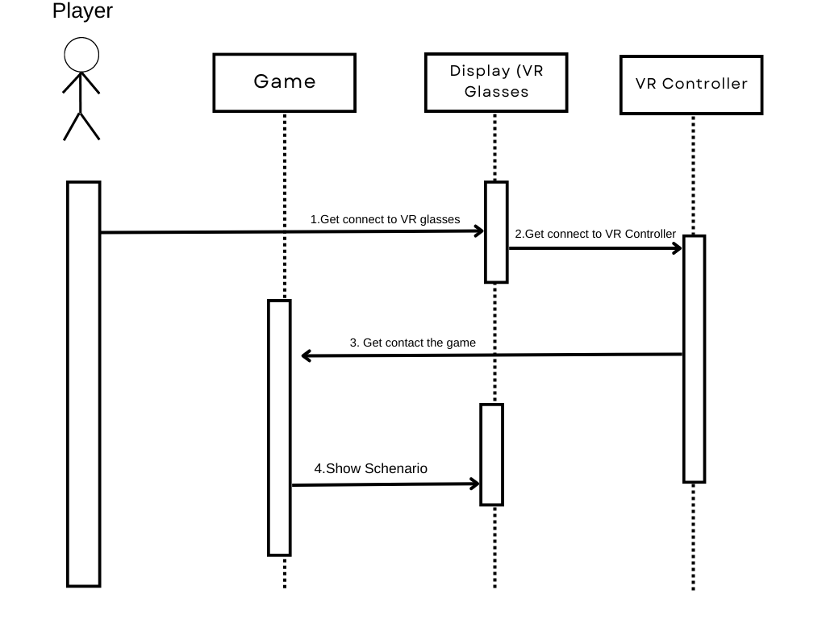

Figure 19: Player for Sequence Diagrams of VR Detective Game

5.1 Our project will follow an event-driven modeling approach in the context of our VR-based detective game. This means that the behavior and flow of the game will primarily be driven by events, such as player actions, system events, or predefined game events. Each event will trigger specific actions, transitions, or changes within the game environment, leading to dynamic and interactive gameplay.

5.2 Since our project will follow an event-driven modeling approach, we will focus on incorporating state machine models to capture the dynamic behavior and transitions within the game. Here are some examples of state machine models that will be relevant to our VR-based detective game:

**- Player State Machine:** The various states that the player character may be in during the game will be represented by the player state machine. This will contain the following states: "Idle," "Moving," "Examining Clues," "Interacting with NPCs," and "Solving Puzzles." Events like player input, arrival at particular areas, interacting with objects, or starting certain actions can cause states to change. When the player chooses an object to investigate, for instance, the state will change from "Idle" to "Examining Clues," bringing about the accompanying interactions and activities specific to that state.

**- Game Progression State Machine:** The state machine for game growth will monitor the overall development of the game. The stages covered by it will be "Introduction," "Investigation Phase," "Clue Collection," "Puzzle Solving," "Suspect Interrogation," and "Case Resolution." Events like achieving goals, gathering important information, hitting milestones, or coming to important decisions will cause states to change. If the right decision is taken, the mission will be successful; if the wrong choice is made, the mission will fail. The game can be played once more by the player. For instance, when the player has gathered all the required clues, the state will change from "Clue Collection" to "Puzzle Solving," signifying the entry into the following game phase.

**- Dialogue State Machine:** The interactions between the player character and non-player characters (NPCs) in the game are controlled by the dialogue state machine . The states that will be covered include "Idle," " Listening, " " Questioning, " "Providing Information ," and "Confrontation." Event like starting discussions, choosing dialogue options , getting responses , or hitting particular discourse milestones can trigger transitions between states. For instance, when a specific question is posed by the player character, the status will change from " Listening " to " Questioning ," triggering the NPC to answer appropriately.

Our VR-based detective game will be able to control the dynamic behavior of the player character, game progression, and dialogue interactions effectively by combining these state machine models, making for a more immersive and captivating gameplay experience.

### 5.6 Activity Diagram

An activity diagram is essentially a flowchart that shows the flow from one activity to another. The process can be described as a system operation.

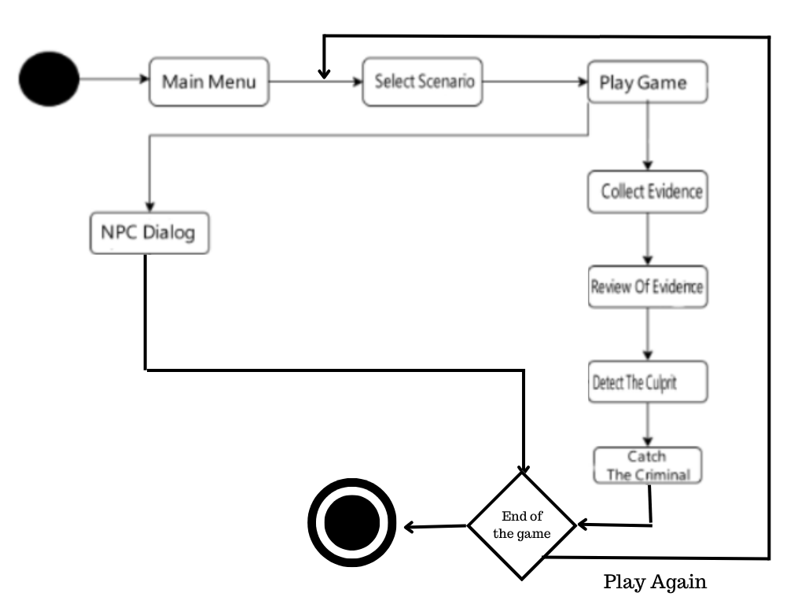

*Figure 20: Activity Diagram for the proposed game*

# CHAPTER 6

## Project Scheduling

### 6.1 Task Network

The task network, a visual depiction of the task flow for a project, is shown in the table below. Sometimes it serves as the method for entering job dependencies and sequence into an automated project scheduling application.

Table 10: Project Tasks of developed system

|  |  |  |  |  |  |
| --- | --- | --- | --- | --- | --- |
| Task ID | Task Name | Duration  /week | Start | Finish | Predec  essors |
| 1 | Market Research | 2 | 17/03/23 | 31/03/23 |  |
| 2 | Determine User and System Requirements and Stakeholder | 4 | 31/03/23 | 28/04/23 | 1 |
| 3 | Determine Functional and Non-Functional Requirements | 2 | 28/04/23 | 12/05/23 | 2 |
| 4 | Requirements Checking (validation) | 1 | 12/05/23 | 19/05/23 | 3 |
| 5 | Feasibility Study | 2 | 19/05/23 | 02/06/23 | 4 |
| 6 | Project Planning | 2 | 02/05/23 | 16/06/23 | 5 |
| 7 | Interaction Models (User Case and Sequence) and Context Diagram | 1 | 16/05/23 | 23/06/23 | 6 |
| 8 | Structural Model (Class) | 1 | 23/06/23 | 30/06/23 | 7 |
| 9 | Behavioral Model (Activity and State) | 1 | 30/06/23 | 07/07/23 | 8 |
| 10 | Mock-up and Interfaces | 1 | 07/07/23 | 14/07/23 | 9 |
| 11 | Planning Report | 0 | 14/07/23 | 14/07/23 | 10 |
| 12 | Writing Senario | 1 | 14/07/23 | 21/07/23 | 11 |
| 13 | Database (project save in github) | 1 | 21/07/23 | 28/07/23 | 12 |
| 14 | Level Design ( demo ) | 2 | 28/0723 | 12/08/23 | 13 |
| 15 | NPC’s Coding & UI | 2 | 12/08/23 | 26/08/23 | 14 |
| 16 | Game Manager & Event System | 3 | 26/08/23 | 16/09/23 | 15 |
| 17 | Game Object Modelling | 2 | 16/09/23 | 30/09/23 | 16 |
| 18 | Level Design ( last version ) | 1 | 30/09/23 | 07/10/23 | 17 |
| 19 | Component Testing | 1 | 07/10/23 | 14/10/23 | 18 |
| 20 | Integration the Systems | 1 | 14/10/23 | 21/10/23 | 19 |
| 21 | Evaluation and Modification the Errors | 1 | 21/10/23 | 29/10/23 | 20 |
| 22 | User Documentation | 1 | 29/10/23 | 06/11/23 | 21 |
| 23 | Project Complete | 1 | Fri 06/11/23 | Thu 13/11/23 | 22 |

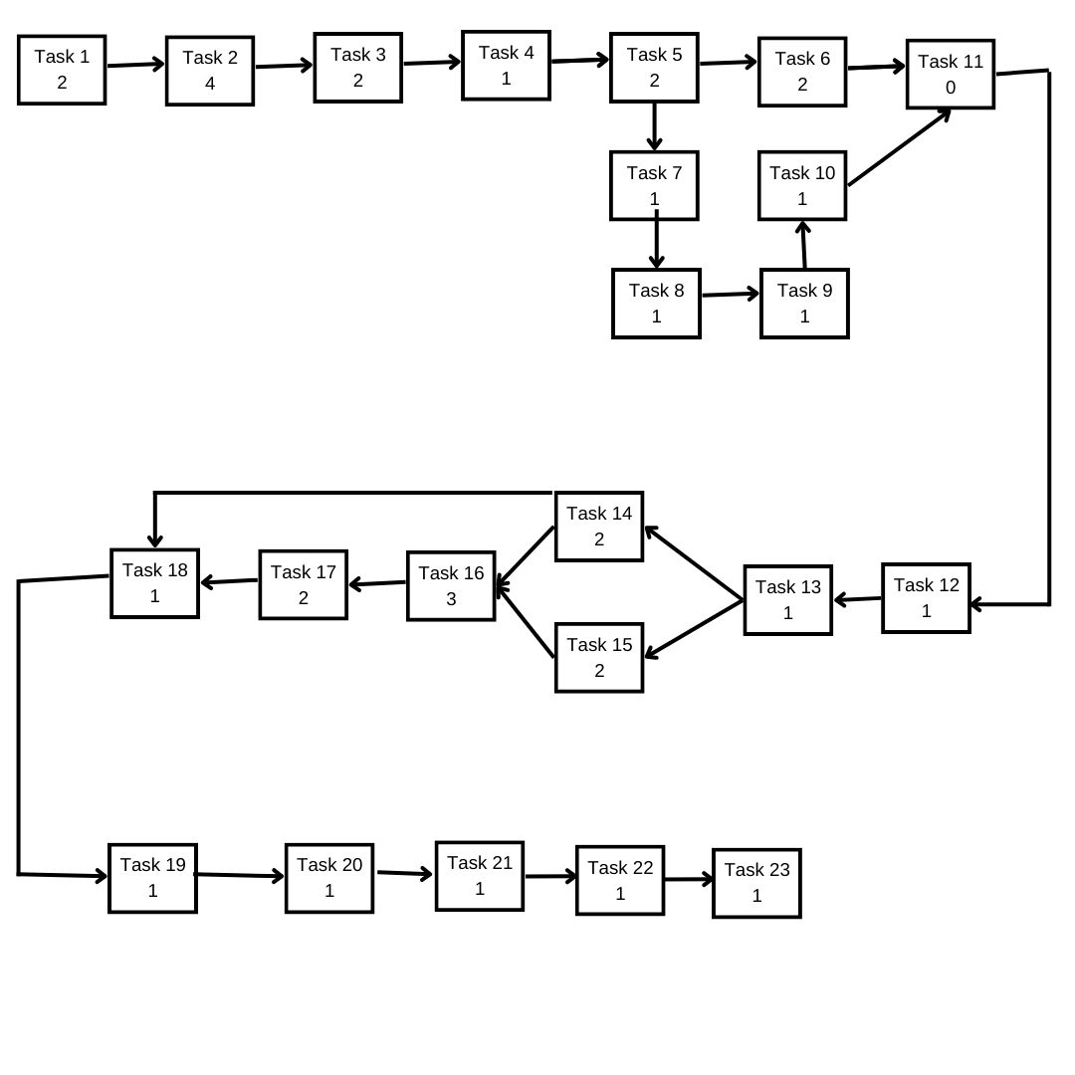

Figure 21: Task Network of developed system

**Path:**

sequence of tasks in a project plan

#1: 1,2,3,4,5,6,11,12,13,14,18,19,20,21,22,23

Cost ( duration ): 2+4+2+1+2+2+0+1+1+2+1+1+1+1+1+1 = 23 week

#2: 1,2,3,4,5,6,11,12,13,14,16,17,18,19,20,21,22,23

Cost ( duration ): 2+4+2+1+2+2+0+1+1+2+3+2+1+1+1+1+1+1 = 28 week

#3: 1,2,3,4,5,6,11,12,13,15,16,17,18,19,20,21,22,23

Cost ( duration ): 2+4+2+1+2+2+0+1+1+2+3+2+1+1+1+1+1+1 = 28 week

#4: 1,2,3,4,5,7,8,9,10,11,12,13,14,18,19,20,21,22,23

Cost ( duration ): 2+4+2+1+2+1+1+1+1+0+1+1+2+1+1+1+1+1+1 = 25 week

#5: 1,2,3,4,5,7,8,9,10,11,12,13,14,16,17,18,19,20,21,22,23

Cost ( duration ): 2+4+2+1+2+1+1+1+1+0+1+1+2+3+2+1+1+1+1+1+1+1= 30 week

#6: 1,2,3,4,5,7,8,9,10,11,12,13,15,16,17,18,19,20,21,22,23

Cost ( duration ): 2+4+2+1+2+1+1+1+1+0+1+1+2+3+2+1+1+1+1+1+1+1= 30 week

**Critical Paths:**

Longest cycle of activities in a planned project, which has to be done on schedule to be complete upon the due date of the project.

Our critical paths: #5 and #6

### 6.2 Gant Chart

An illustration of a project timetable is a Gantt chart. The timetable for the project is shown in the chart below.

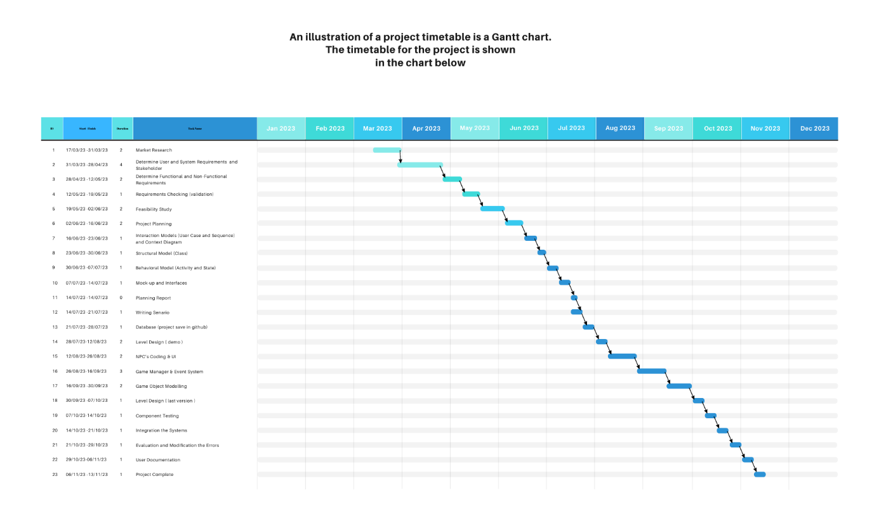

Figure 22: Task Network of developed system

### 6.3 Pert Chart

This section will demonstrate the Pert chart, a statistical tool used in project management that was created to evaluate and display the steps necessary to complete a certain project.

Table 12: Pert Char of developed system

|  |  |  |  |  |
| --- | --- | --- | --- | --- |
| Task# | Task | Proceed ID | Succ. ID | Estimated time |
|
|
| 1 | Market Research | 1 | 2 | 1 |
|
|
| 2 | Determine User and System Requirements and Stakeholder | 2 | 3 | 4 |
|
|
| 3 | Determine Functional and Non-Functional Requirements | 3 | 4 | 2 |
|
|
| 4 | Requirements Checking (validation) | 4 | 5 | 2 |
|
|
| 5 | Feasibility Study | 5 | 6 | 1 |
|
|
| 6 | Project Planning | 6 | 7 | 2 |
|
|
| 7 | Interaction Models (User Case and Sequence) and Context Diagram | 6 | 8 | 1 |
|
|
| 8 | Structural Model (Class) | 8 | 9 | 1 |
|
|
| 9 | Behavioral Model (Activity and State) | 9 | 10 | 1 |
|
|
| 10 | Mockup and Interfaces | 10 | 11 | 1 |
|
|
|  | Dummy Task | 7 | 12 |  |
|
|
|  | Dummy Task | 11 | 12 |  |
|
|
| 11 | Planning Report | 12 | 13 | 0 |
|
|
| 12 | Writing Senario | 13 | 14 | 1 |
|
|
| 13 | Database (project save in github) | 14 | 15 | 1 |
|
|
| 14 | Level Design | 14 | 16 | 2 |
|
|
|  | Dummy Task | 15 | 17 |  |
|
|
|  | Dummy Task | 16 | 17 |  |
|
|
| 15 | NPC’s Coding & UI | 17 | 18 | 2 |
|
|
| 16 | Game Manager & Event System | 18 | 19 | 3 |
|
|
| 17 | Game Object Modelling | 19 | 20 | 2 |
|
|
| 18 | Level Design ( last version ) | 20 | 21 | 1 |
|
|
| 19 | Component Testing | 21 | 22 | 1 |
|
|
| 20 | Integration the Systems | 21 | 23 | 1 |
|
|
| 21 | Evaluation and Modification the Errors | 22 | 24 | 1 |
|
|
| 22 | User Documentation | 23 | 24 | 1 |
|
|
|  | Dummy Task | 24 | 25 |  |
|
|
|  | Dummy Task | 24 | 26 |  |
|
|
| 23 | Project Complete | 25 | 26 | 1 |
|
|

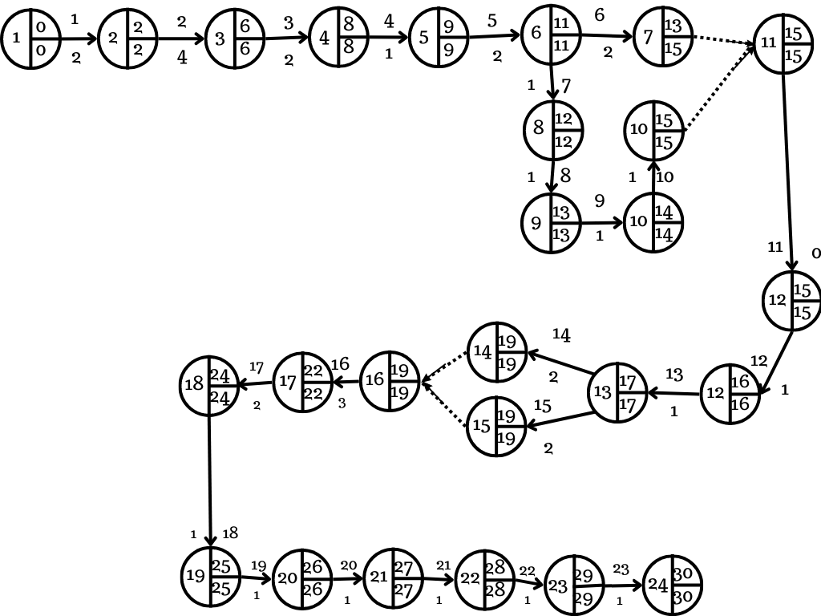

Figure 23: Systems Pert Chart of developed system

# CHAPTER 7

## Mock-up and Interfaces

### 7.1 Mock-up

#### 7.1.1 Main Menu

The main menu of the game contains buttons that can access sessions. The “NEW GAME” button allows the player to create a game area that players play. The “SETTINGS” button allows the player to set the game the way player wants such as controller settings. The “LOAD GAME” button allows players to continue playing the saved game that played before. “EXIT” button allows to close the game directly.

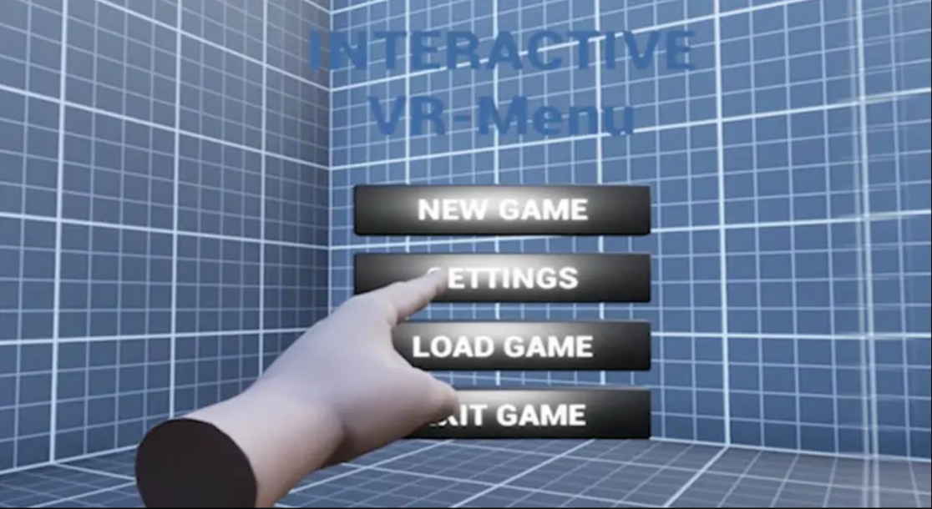

Figure 24: Main Menu

## 

**7.1.2 Game Session**

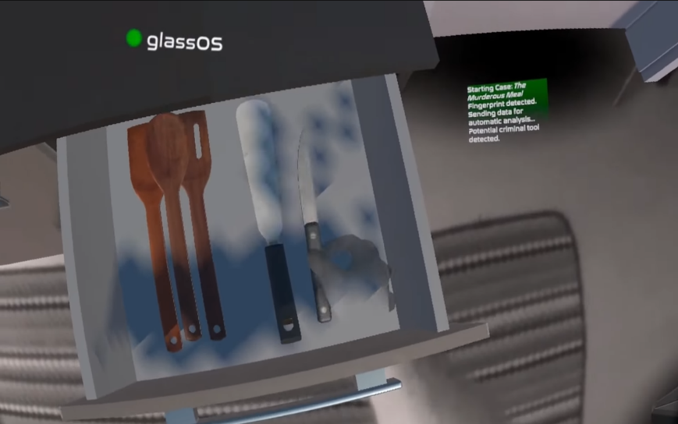

Figure 25 Game Session Mock-up

In the game session, players can interact with virtual world. Virtual world consist of crime scenes and non crime scenes as well. Players can interact with non player characters (NPCs) some objects such as materials that could be evidences or another random materials that have nothing to do with the case.

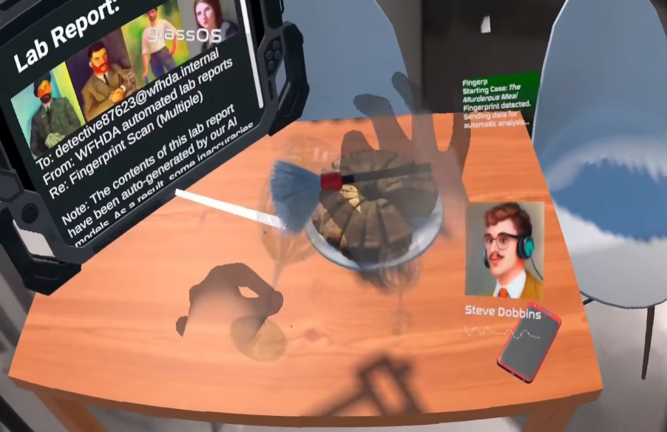

*Figure 26: Game Session Mock-up*

#### 7.1.3 Deployment

Players receive new missions on this part of the game by interacting with a NPC ex collague.

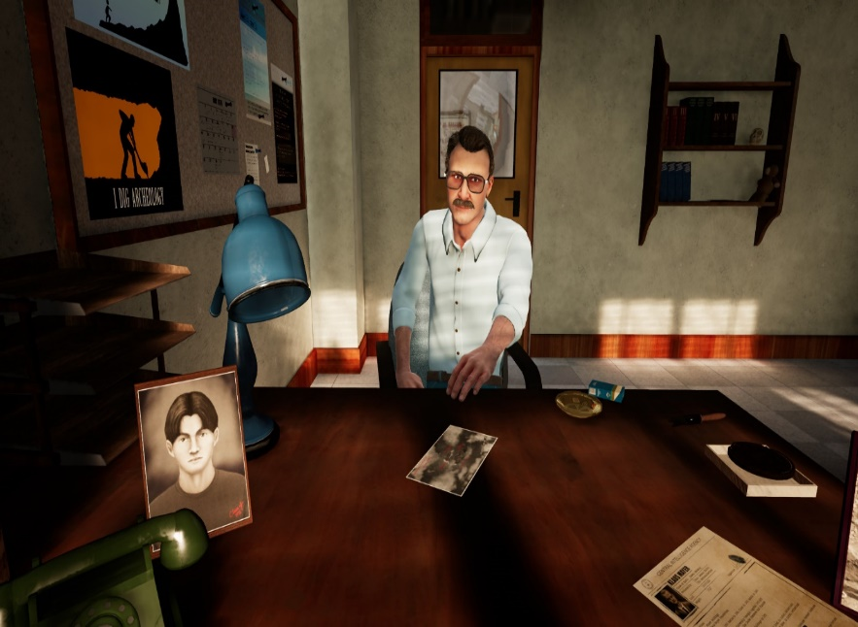

Figure 27:Deployment Mock-up

#### 7.1. 4 Crime Scene

Crime scene is the actual environment which the game takes place in. Players can collect clues, evidences, informations and documents at crime scene which could be useful for the process of the case.

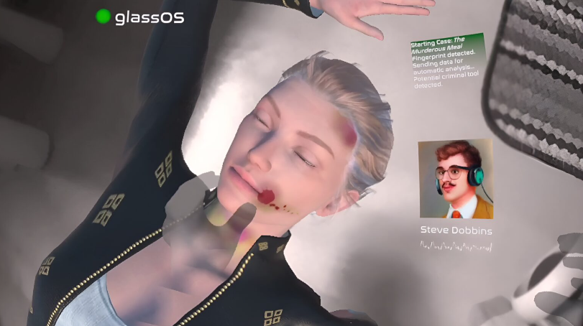

Figure 28:Crime Scene Mock-up

#### 7.1.5 Mini Game

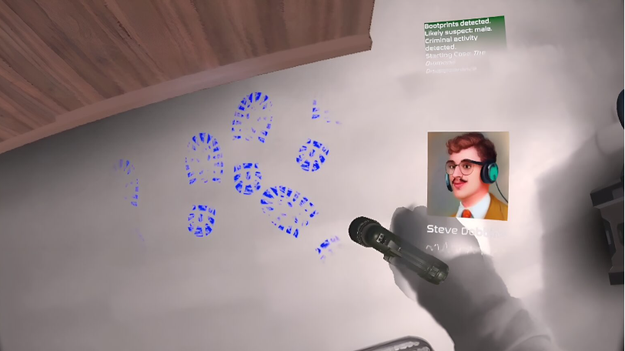

Figure 29:Mini Game Mock-up

While collecting of the evidences players need to solve the puzzles in minigames to have process on the case.athering Evidenceith the recovering of the clues and evidences playercollect more information about the possible culprit. That includes collecting of fingerprints, footprints, stain of the blood of victim or couple drops of the blood of the culprit etc. No process can be done on the case without discovering new informations about the case and players collect informations via gathering evidences.

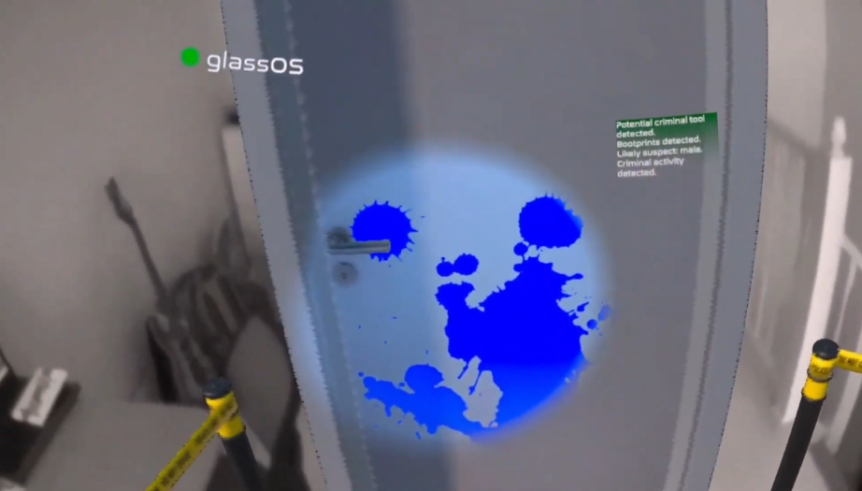

Figure 30: Mini Game Mock-up

#### 7.1.6 Interregotion of the Suspects

Players collect more informations with interregotion process of suspected NPCs (non player characters) that are somehow releted to case by found evidences or clues.

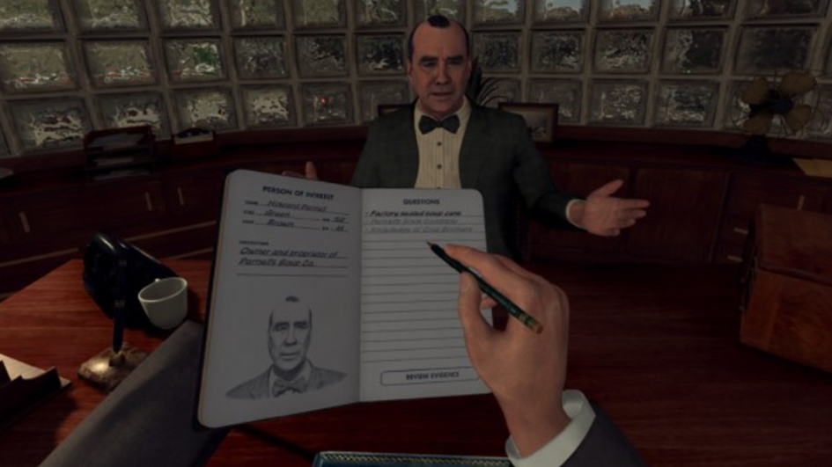

Figure 31: Interregotion Mock-up

#### 7.1.7 Comparasion of Data

Players review the dataset of evidences, clues and interregotions to do a reasonable reconsideration to get a step closer to the actual culprit.

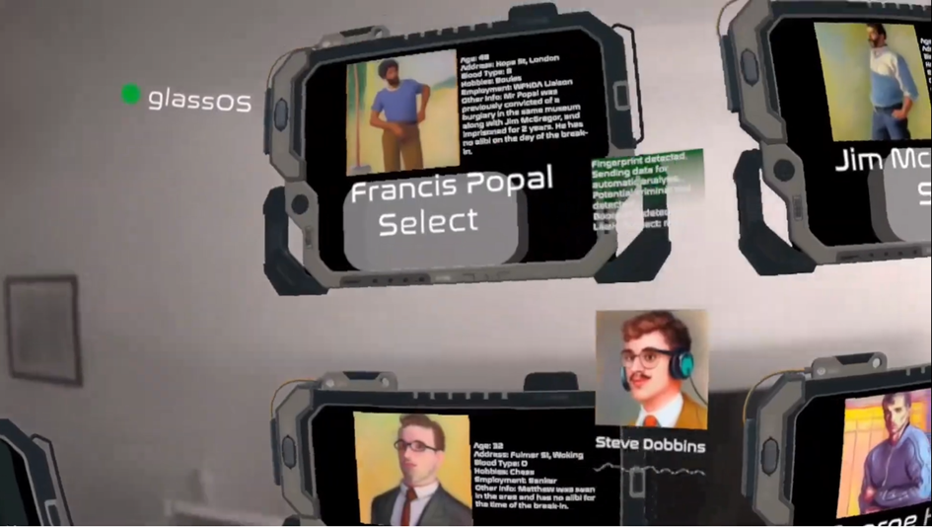

Figure 32: Comparasion of Data Mock-ups

#### 7.1.8 Identification of the Culprit

Players decide who the culprit is based on the logical information they have obtained. The case will be successfully closed if the players acuse the right person.

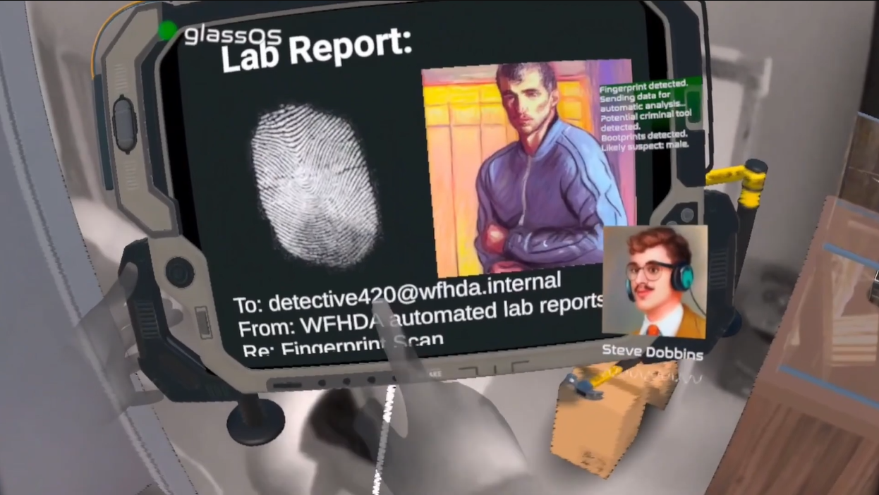

Figure 33: Identification of the Culprit Mock-up

### 7.2 Interfaces

In the Interface section, it is explained how the user and people in the background will see the application. The interface that users and people who produce the application in the background see may be different. In our project, there will be no admin interface, as stated in the sequence diagram, the admin will only solve the job with codes.

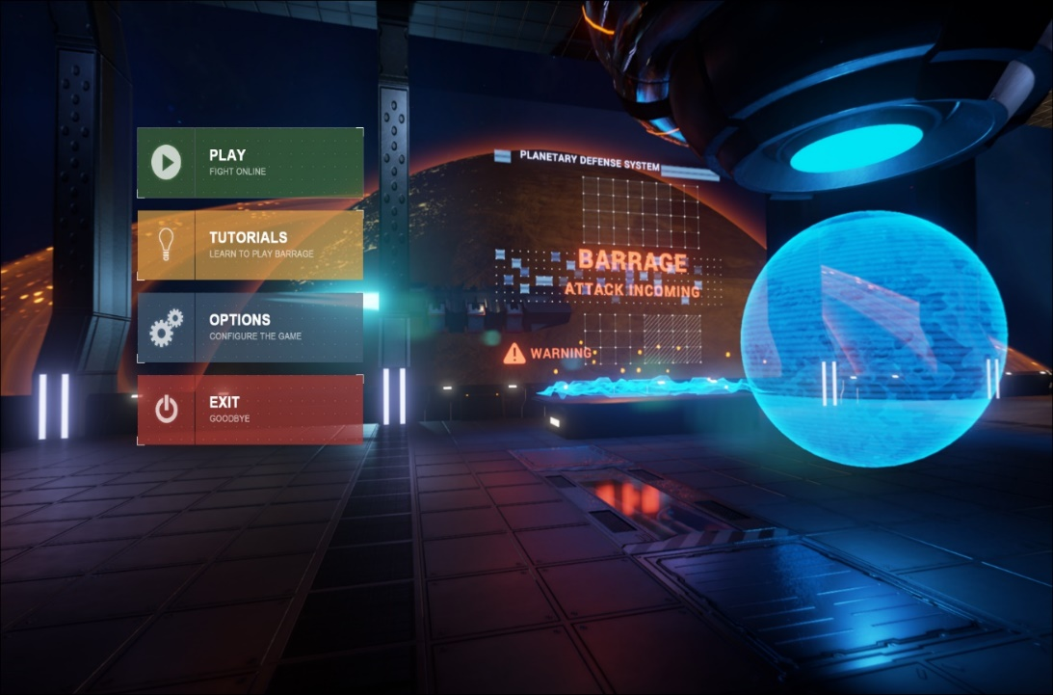

Figure 34 : Systems Tester & Player Interface, showing main menu

#### 7.2.1 Admin & Tester interface

Tester and user will have the same view. What you see in the figure is the interface we see before starting the game. From here, the game is entered or the necessary in-game settings are adjusted according to the person.

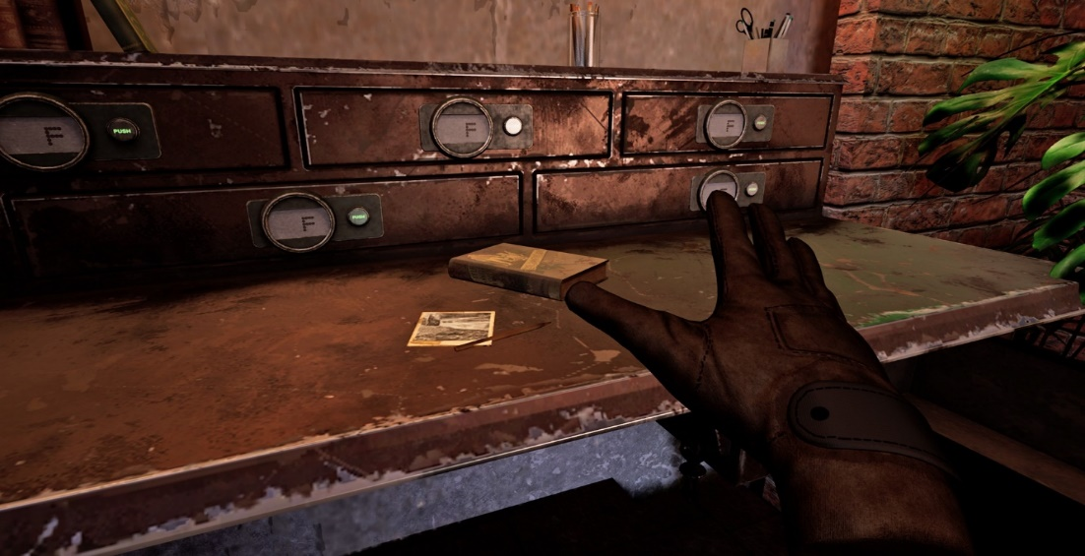

Figure 35 : Systems Tester & Player Interface, showing game

# CHAPTER 8

## Result and Conclusion

This document represents our game, which we will prepare to provide a realistic and immersive experience. We decided to use VR technology in order to provide a more realistic experience to the players and from among the few options we considered, we decided that it would be a detective game. We have planned a crime scenario for our VR detective game. Interacting with the environment is very important in detective games. Today's VR technologies provide this interaction to a more realistic extent. That's why we decided to produce our game on the VR platform. The person playing the game will play a detective who interacts with clues and NPCs (non-player characters) to try to find the culprit. In this game process, we will develop the necessary infrastructures to transfer realism to the player, leaving the player alone with a more realistic experience. In this project, we want to show that although we are making a VR game, VR technology will be used in other fields as well.

The covid 19 pandemic that broke out in the past years and the earthquake a few months ago are occured examples that disrupt the education system for unexpected reasons. With our project, we also aim to enable the police to acquire effective skills that can be practiced in a practical way and transferred to real life.

# CHAPTER 9

## Glossary

Terms involled in this Project is showed in Table. Table hist of the Glossary.

Table 13 :List of Glossary

|  |  |
| --- | --- |
| VR(Virtual Reality) | This is the simulation that is computer-generated of a three-dimensional environment that can be interacted with in a seemingly real or physical way, using specialized equipment such as a headset and gloves |
|  |
|  |
|  |
|  |
|  |
| Player | A person who plays a game, either alone or with others |  |
|  |
|  |
|  |
|  |
|  |
| Mini Games | Short, self-contained games within a larger game, often used as a break or change of pace from the main gameplay. |  |
|  |
|  |
|  |
|  |
|  |
| Playground | A place, often in a virtual environment, where people can play games or engage in other forms of leisure activity. |  |
|  |
|  |
|  |
|  |
|  |
| Controller | A device used to control game or application such as gamepad or keyboard |  |
|  |
|  |
|  |
|  |
|  |
| Game Engine | A software platform designed for the creation and development of video games, providing various tools and features for creating and running games. |  |
|  |
|  |
|  |
|  |
|  |
| Visual Scripting | A method of creating and controlling software or systems using visual representations of actions and logic, rather than writing code. |  |
|  |
|  |
|  |
|  |
|  |
| Module | A self-contained unit of software that performs a specific function and can be used in larger software applications |  |
|  |
|  |
|  |
|  |
|  |
| SDK(Software Developement Kit) | A set of tools and resources that allows developers to create applications or software for a specific platform |  |
|  |
|  |
|  |
|  |
|  |
| Gameplay | The experience of playing a game, including the rules, challenges, and mechanics that make up the game |  |
|  |
|  |
|  |
|  |
|  |
| Training | The process of learning and practicing skills or techniques, often in the context of a game or application |  |
|  |
|  |
|  |
|  |
|  |
| Actions | The behaviors or tasks that a game or application is designed to perform Indie developers  Independent game developers, often working on small or self-funded projects |  |
|  |
|  |
|  |
|  |
|  |
| Low Polly | A style of computer graphics that uses simple, flat-shaded polygons to create 3D models, often with a minimalistic or stylized aesthetic. |  |
|  |
|  |
|  |
|  |
|  |
| Rendering | The process of creating a visual representation of 3D models or scenes, often using computer graphics software |  |
|  |
|  |
|  |
|  |
|  |
| NPC | abbreviation for non-playable character: a character in a computer game that is not controlled by someone playing the game: There are eight NPCs in "Fallout 3". |  |
|  |
|  |
|  |
|  |
|  |
| Event System | The Event System is a way of sending events to objects in the application based on input, be it keyboard, mouse, touch, or custom input. The Event System consists of a few components that work together to send events. |  |
|  |
|  |
|  |
|  |
|  |
| Game Manager | GameManager. A simple unity game management system to handle loading a game, its levels and saving the levels data such as score, gained money, level number. |  |
|  |
|  |
|  |
|  |
|  |
| Blender 3D | Blender 3D is a free, open-source computer graphics program that specializes in creating three-dimensional assets and scenes for video games, animations, and renders. |  |
|  |
|  |
|  |
|  |
|  |

# CHAPTER 10

## References

[1] Unity Technologies. (2022). Unity - Manual: Unity User Manual (2021.2 LTS). https://docs.unity3d.com/Manual/index.html

[2] Brackeys. (2022). Unity Tutorials.  <https://www.youtube.com/c/Brackeys/playlists>

[3]Oculus Developers. (2022). Oculus Developer Hub. <https://developer.oculus.com/documentation/unity/>

[4] Microsoft. (2022). C# programming guide. https://docs.microsoft.com/en-us/dotnet/csharp/programming-guide/

[5] Zenva Academy. (2022). Unity Tutorials.  [https://academy.zenva.com/product-category/game-development/unity /](https://academy.zenva.com/product-category/game-development/unity%20/)

[6] Rockstar games <https://www.rockstargames.com/games> <https://www.rockstargames.com/games/lanoire>

[7] How to Publish your Game on Steam (and Why You Should) | GDevelop

<https://gdevelop.io/tr-tr/page/how-to-publish-your-game-on-steam-and-why-you-should>

[8] Example of VR games <https://store.steampowered.com/app/1610670/Detective_VR_NFT_secret_Files/>

[9] Steam Works https://partner.steamgames.com/?goto=%2Fhome